Implementation Manual for Decreasing Telemetry Utilization

System-wide EHR Implementation Details
Prior to our telemetry improvement project, when placing an order for telemetry, the only required fields asked whether the monitor could be removed for out of unit procedures and/or for showering. When telemetry was ordered, no indication was required. The order continued indefinitely or until discontinued by a provider.
In conjunction with the Cardiology Division, we adapted the American Heart Association (AHA) guidelines for telemetry monitoring to draft a list of appropriate indications for telemetry monitoring and associated recommended durations for monitoring, based on the indication.¹ We then built these questions into our EHR ordering system.
Changes to the EHR order:
- Made questions for removal for procedures and shower optional
- Required indication for monitoring to be chosen from drop down list
- Required duration for monitoring to be selected (24, 48, 72 hours, continuous)
- Added clinical decision support in the form of a list of common clinical conditions for which telemetry is often ordered but not indicated
- Added a link to the AHA guidelines within the order
- Added a communication order for the RN to discontinue the order when it expires
University of Utah Recommended Duration of Monitoring by Clinical Indication:
24 Hours Suggested
- Post-cardiac procedure or cardioversion
- Severe electrolyte abnormalities
- Syncope, suspected cardiac etiology
- Initiation of a medication requiring telemetry monitoring per institutional parenteral drug policy
- Other indications
48 Hours Suggested
- Acute coronary syndrome (ACS) or post-myocardial infarction (MI)
- Atrial fibrillation, new onset or uncontrolled rate
- Myocarditis or pericarditis
- QT prolongation or overdose of drug/medication with potential for arrhythmia
72 Hours Suggested
- Post-operative complex major surgery, high cardiac risk
- Arrhythmia, not atrial fibrillation, with suspected or proven hemodynamically significant arrhythmia
- Anti-arrhythmic drug initiation
Indefinite Monitoring Suggested
- Stroke or transient ischemic attack (TIA)
- Decompensated heart failure
- Post-operative cardiothoracic surgery

Baseline Telemetry Order
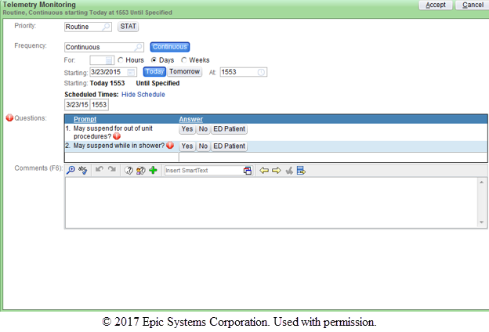

New Telemetry Order
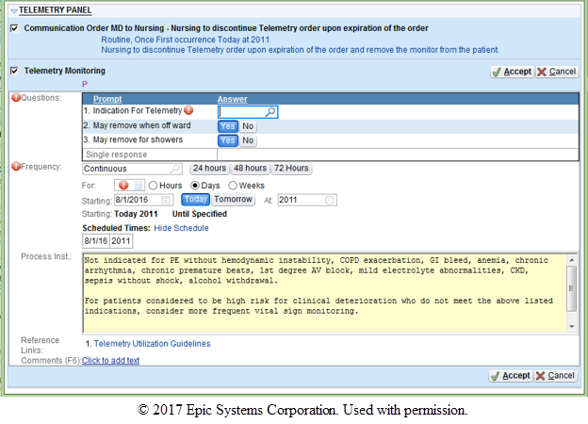

New Telemetry Order – Indications with Durations Drop-Down List
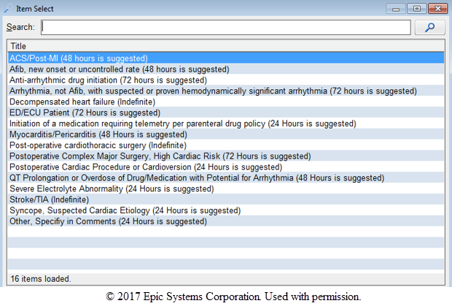

Hospitalist Group Intervention Details
- Provider Education:
  - Hospitalist Education: Attending physicians as well as advanced practice providers (APPs) on the hospitalist service all received a single 40-minute educational lecture, provided by the first author, regarding telemery monitoring.
  - Resident Education: For resident education, a single noon conference lecture was given by one of the authors of this study. Residents rotating on the hospitalist service also participate in a weekly 15-minute quality improvement series. Appropriate telemetry utilization was covered in this curriculum approximately every 6 weeks.
Educational content covered in these lectures:
- Guidelines for telemetry monitoring^{1, 2}
- Society of Hospital Medicine’s (SHM) Choosing Wisely campaign³
- Potential harms of telemetry overutilization⁴
- List of common clinical conditions for which telemetry is not indicated, but often used⁵
- Prior studies evaluating the frequency at which telemetry changes outcomes and risk of cardiac arrest of patients monitored on telemetry⁶⁻¹²
- Summary of prior interventions aimed to reduce unnecessary telemetry monitoring¹³⁻¹⁵
- Review of our institution’s baseline telemetry utilization data
- Outline of our intervention to reduce unnecessary telemetry

- Removal of telemetry order from admission order sets: Prior to the implementation of our QI project to reduce unnecessary telemetry monitoring, an order for telemetry monitoring was present in our general medicine admission order set which is used for the majority of hospitalist admissions. Thus, when placing admission orders, providers could easily select telemetry monitoring from within the order set. As part of the hospitalist service intervention, this order was removed from the admission order set. Now, when a provider wants to place a patient on telemetry, they must search for and place this order separately, rather than selecting a pre-existing order on the admission order set. The intention of this change was to require an active decision to monitor a patient, rather than having it be suggested to the ordering provider.

Baseline - Telemetry Order within the General Internal Medicine Admission Order Set
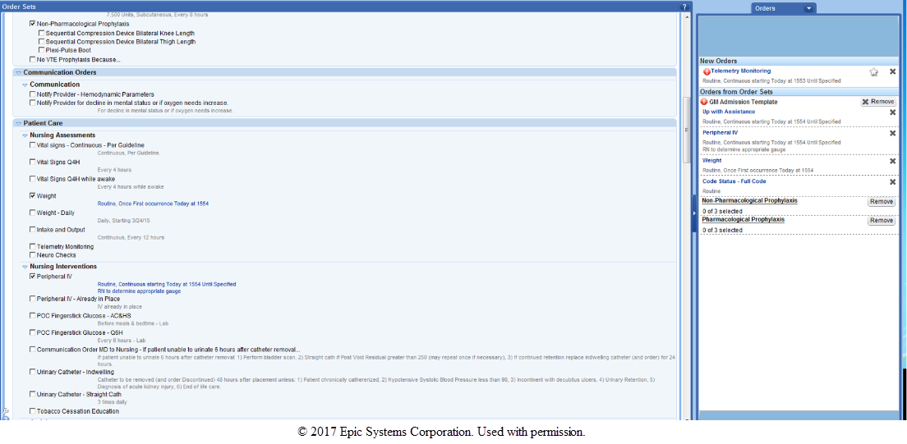

- Standardization of Rounds: We attempted to standardize housestaff-attending rounds to encourage discussion of telemetry daily. Our hospitalist group has previously used a “Rounding Checklist” which in addition to telemetry addresses laboratory ordering, pain control, presence of central lines or tubes, nursing presence on rounds, family communication, and follow-up needed. This checklist has been described previously, in relationship to a laboratory reduction initiative on the hospitalist service¹⁶. The third-year medical student was responsible for ensuring that all items on the checklist were covered daily for each patient. The expectation was that the presence or absence of telemetry monitoring would be brought up for all patients daily, and for patients on telemetry, a discussion would occur as to whether the patient had an ongoing indication for monitoring. The intention of this intervention was to ensure providers were aware which of their patients were on telemetry, so they could consider discontinuation, when appropriate.

“Rounding Checklist”
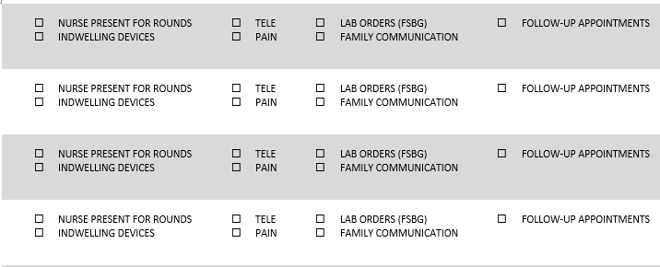

- Routine Feedback: The hospitalist service has a weekly 1 hour group meeting. Once a month these meetings are devoted to a discussion of ongoing quality improvement initiatives. As part of these monthly QI meetings, hospitalists received feedback in the form of PowerPoint slides demonstrating telemetry utilization within the entire institution, as well as the hospitalist group as a whole. No individual provider data was given or discussed. After the meeting, the PowerPoint slide deck is emailed to all providers in the group, so that the information covered is available to those who were unable to attend the meeting in person.

- Group Financial Incentive: Our institution has a program designed to encourage physician driven cost-saving improvement projects. As part of this program, the hospital will give back 50% of any realized first-year cost savings to divisions that successfully implement such a project. The incentive can support future quality improvement projects, but there is no individual physician payment or salary support. For this project, the savings was split between the Division of Cardiology and the Division of General Internal Medicine. As a result of the incomplete and conservative method used to calculate cost savings, the amount of money each Division received was under $20,000, and this was not felt to be a significant contributor to our telemetry utilization results.

References:
1. Drew BJ, Califf RM, Funk M, et al. Practice standards for electrocardiographic monitoring in hospital settings: an American Heart Association scientific statement from the Councils on Cardiovascular Nursing, Clinical Cardiology, and Cardiovascular Disease in the Young: endorsed by the International Society of Computerized Electrocardiology and the American Association of Critical-Care Nurses. Circulation. Oct 26 2004;110(17):2721-2746.
2. Henriques-Forsythe MN, Ivonye CC, Jamched U, Kamuguisha LK, Olejeme KA, Onwuanyi AE. Is telemetry overused? Is it as helpful as thought? Cleve Clin J Med. Jun 2009;76(6):368-372.
3. Bulger J, Nickel W, Messler J, et al. Choosing wisely in adult hospital medicine: five opportunities for improved healthcare value. J Hosp Med. Sep 2013;8(9):486-492.
4. Chen S, Zakaria S. Behind the monitor--the trouble with telemetry: a teachable moment. JAMA Intern Med. Jun 2015;175(6):894.
5. Najafi N, Auerbach A. Use and outcomes of telemetry monitoring on a medicine service. Arch Intern Med. Sep 24 2012;172(17):1349-1350.
6. Dhillon SK, Rachko M, Hanon S, Schweitzer P, Bergmann SR. Telemetry monitoring guidelines for efficient and safe delivery of cardiac rhythm monitoring to noncritical hospital inpatients. Crit Pathw Cardiol. Sep 2009;8(3):125-126.
7. Sivaram CA, Summers JH, Ahmed N. Telemetry outside critical care units: patterns of utilization and influence on management decisions. Clin Cardiol. Jul 1998;21(7):503-505.
8. Estrada CA, Rosman HS, Prasad NK, et al. Evaluation of guidelines for the use of telemetry in the non-intensive-care setting. J Gen Intern Med. Jan 2000;15(1):51-55.
9. Estrada CA, Rosman HS, Prasad NK, et al. Role of telemetry monitoring in the non-intensive care unit. Am J Cardiol. Nov 01 1995;76(12):960-965.
10. Estrada CA, Prasad NK, Rosman HS, Young MJ. Outcomes of patients hospitalized to a telemetry unit. Am J Cardiol. Aug 15 1994;74(4):357-362.
11. Schull MJ, Redelmeier DA. Continuous electrocardiographic monitoring and cardiac arrest outcomes in 8,932 telemetry ward patients. Acad Emerg Med. Jun 2000;7(6):647-652.
12. Mohammad R, Shah S, Donath E, et al. Non-critical care telemetry and in-hospital cardiac arrest outcomes. J Electrocardiol. May-Jun 2015;48(3):426-429.
13. Dressler R, Dryer MM, Coletti C, Mahoney D, Doorey AJ. Altering overuse of cardiac telemetry in non-intensive care unit settings by hardwiring the use of American Heart Association guidelines. JAMA Intern Med. Nov 2014;174(11):1852-1854.
14. Leighton H, Kianfar H, Serynek S, Kerwin T. Effect of an electronic ordering system on adherence to the American College of Cardiology/American Heart Association guidelines for cardiac monitoring. Crit Pathw Cardiol. Mar 2013;12(1):6-8.
15. Boggan JC, Navar-Boggan AM, Patel V, Schulteis RD, Simel DL. Reductions in telemetry order duration do not reduce telemetry utilization. J Hosp Med. Dec 2014;9(12):795-796.
16. Yarbrough PM, Kukhareva PV, Horton D, Edholm K, Kawamoto K. Multifaceted intervention including education, rounding checklist implementation, cost feedback, and financial incentives reduces inpatient laboratory costs. J Hosp Med. May 2016;11(5):348-354.

