Appendix 1 – Detailed Methods

Expert Panel Formulation
The Society of Hospital Medicine (SHM) Board of Directors delegated the SHM Education Committee with the task of developing recommendations on the use of ultrasound to guide bedside procedures. The chair of the SHM Education Committee appointed two chairs to lead the guideline development project, a subject matter expert in POCUS and a senior member of the education committee. An additional subject matter expert co-chair was added given the broad scope of the project.

The SHM POCUS Task Force was assembled to carry out this guideline development project under the direction of the SHM Board of Directors, Director of Education, and Education Committee. All expert panel members were physicians or advanced practice providers with expertise in POCUS. Expert panel members were divided into working group members, external peer reviewers, and a methodologist. All expert panel members and two members of the SHM education committee were voting members. Working group members were required to be hospitalists per the SHM definition (1) and have expertise in POCUS. External peer reviewers were nationally recognized physicians with expertise in POCUS from different specialties, including emergency medicine, critical care, anesthesiology, pulmonary/critical care, internal medicine, and cardiology. All external peer reviewers had to have past experience in developing point-of-care ultrasound guidelines, either serving as a chair or member of a guideline development panel. A methodologist with clinical expertise in POCUS and past experience in leading development of POCUS guidelines served on the expert panel. Non-voting Task Force members included a medical librarian, the SHM Education Committee Chair, and the SHM Director of Education (see Acknowledgements).

Disclosures
This project did not receive any funding from any external sponsors or SHM. All Task Force members voluntarily participated, and none received an honorarium for participation. There was no industry input in the development of these guidelines, nor industry presence during any conference calls or meetings. All SHM POCUS Task Force members were required to disclose any potential conflicts of interests. Signed disclosure statements of all members were reviewed by the SHM Director of Education and an SHM POCUS Task Force chair prior to inclusion on the Task Force. One of the thoracentesis working group members, two of the external peer reviewers, and one of the chairs reported financial relationships. Decisions to approve participation were guided by the 2008 and 2011 Institute of Medicine (IOM) reports on development of trustworthy Clinical Practice Guidelines (2,3). Prior to submission of this manuscript, all Task Force members were required to submit an updated conflict of interest disclosure statement for inclusion as an author or collaborator on the final manuscript. Conflict of Interest disclosures are included in Appendix 2.

Literature Search Strategy
The literature search was conducted in two independent phases. The first phase included independent literature searches conducted by working group members themselves. Each thoracentesis working group member and two co-chairs independently performed literature searches to avoid selection bias. Potentially relevant references were compiled, discussed during weekly conferences calls, and selected references were summarized in a shared, online data table. Based on the references gathered during the first track of literature searches, key clinical questions and draft recommendations were prepared prior to conducting a systematic literature search.

The second phase was a systematic literature search conducted by a medical librarian for each key clinical question and draft recommendation. The Medline, Embase, CINAHL, and Cochrane medical databases were searched from 1975 to September 2015 initially. Updated searches were conducted in November 2016 and in August 2017. Search limiters were English language and adults only. Search terms and specific search strings for each draft recommendation are shown in Appendix 3. Articles identified by the comprehensive literature search were systematically screened and selected. All article abstracts were first screened for relevance by at least two members of the working group. Full-text versions of screened articles were reviewed, and articles on the use of ultrasound to guide thoracentesis were selected. Articles that discussed thoracentesis without ultrasound guidance were excluded. Additionally, the following article types were excluded: non-English language, non-human, age<18, meeting abstracts, meeting posters, letters, and editorials. All systematic reviews, meta-analyses, randomized controlled trials, and observational studies of ultrasound-guided thoracentesis were screened and selected. References listed in narrative review articles were reviewed to ensure no important studies were missed. Any disagreements about article selection were discussed during weekly conference calls and final selection was based on consensus of the thoracentesis working group. Findings from the selected articles were abstracted into a data table. The selected literature was incorporated into the draft recommendations and rationales during a series of weekly conference calls. All full text articles were shared electronically amongst the working group members. See Appendix 3, Figure 1.

Development of Clinical Recommendations and Consensus
These recommendations were developed using the RAND Appropriateness Method that required panel judgment and consensus. Details about the RAND Appropriateness Method to gather consensus have been previously published (4). Voting members of the SHM POCUS Task Force reviewed and voted on the draft recommendations using the RAND appropriateness method. Panel members were advised to vote on appropriateness based on these 5 transforming factors: 1) Problem priority and importance, 2) Level of quality of evidence, 3) Benefit / harm balance, 4) Benefit / burden balance, 5) Certainty / concerns about PEAF (Preferences / Equity Acceptability / Feasibility).

The draft recommendations were uploaded into an internet-based electronic data collection tool (Redcap™) (Appendix 4). An invitation email was sent to panel members that included a link to vote and a data table with hyperlinks to view PDF’s of reference articles online. Panel members participated in two rounds of electronic voting in December 2016 and January 2017. Voting was conducted using a 9-point Likert scale, where 1 denotes extremely inappropriate and 9 extremely appropriate with three zones: 1–3 inappropriate zone, 4–6 uncertain zone, and 7–9 appropriate zone. Based on the feedback from the first round of voting, minor modifications were made to the draft recommendations classified as having “disagreement.” The RAND appropriateness method was applied using expert consensus for recommendations. The degree of consensus was assessed using the RAND algorithm during the 2 rounds of voting (see below, Figure 1). Establishing a recommendation required at least 70% agreement and a strong recommendation required 80% agreement following the RAND rules (see below, Table 1). Disagreement was defined as >30% of panelists voting outside of the zone of the median.

The Thoracentesis Working Group members reviewed the voting results and narrative comments, to revise the draft recommendations. Any recommendations with disagreement were removed. Some phrases and references from recommendations with disagreement were incorporated in relevant recommendations without disagreement. Recommendations were classified as strong or weak/conditional based on preset rules defining the panel’s level of consensus, which determined the wording for each recommendation (see below, Table 2). For strong recommendations, the phrase ‘‘we recommend’’ was used, along with the verb ‘‘must’’ or ‘‘should’’ depending upon whether or not the degree of consensus was perfect vs. very good, respectively. For weak or conditional recommendations, the phrase ‘‘we suggest’’ was used, along with the verb “can” or ‘‘may’’ depending on whether or not the degree of consensus was good (4).

The final recommendations were reviewed and revised by a writing committee, which consisted of the Thoracentesis Working Group, chairs of all 5 working groups, and 2 of the Task Force co-chairs. The writing group was tasked with final review of each recommendation’s wording, clinical relevance, usability, and feasibility. The revised manuscript underwent external peer review by POCUS experts from different subspecialties that are members of SHM POCUS Task Force. Final review of the guidelines document was performed by all members of the SHM POCUS Task Force, SHM Education Committee, and SHM Board of Directors. The SHM Board of Directors endorsed the document prior to submission to the Journal of Hospital Medicine.

Figure 1 – RAND Algorithm

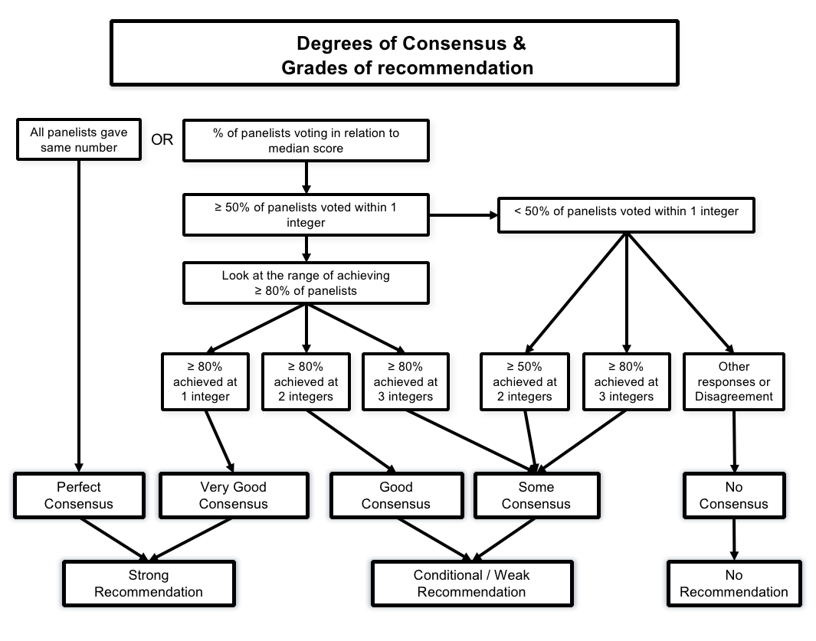

Table 1 – Definitions of Levels of Consensus

Term | Definition
Perfect consensus | All respondents agree on one number between 7-9
Very good consensus | Median and middle 50% (interquartile range) of respondents are found at one integer (e.g., median and interquartile range are both at 8) or 80% of respondents are within one integer of the median (e.g., median is 8, 80% respondents are from 7 to 9)
Good consensus | 50% of respondents are within one integer of the median (e.g., median is 8, 50% of respondents are from 7 to 9) or 80% of the respondents are within two integers of the median (e.g., median is 7, 80% of respondents are from 5 to 9).
Some consensus | 50% or respondents are within two integers of the median (e.g., median is 7, 50% of respondents are from 5 to 9) or 80% of respondents are within three integers of the median (e.g., median is 6, 80% of respondents are from 3 to 9).
No consensus | All other responses. Any median with disagreement

Table 2 – Degree of Consensus, Strength of recommendation, and Wording

Degree of consensus | Strength of recommendation | Wording [Function of voting]
Perfect consensus | Strong | recommend – must/to be/will
Very good consensus | Strong | recommend – should be/can
Good consensus | Weak/Conditional | suggest – to do
Some consensus | Weak/Conditional | suggest – may do
No consensus  Disagreement | NO | No recommendation was made regarding

References
1. Definition of hospitalist available at: https://www.hospitalmedicine.org/Web/About_SHM/Hospitalist_Definition/About_SHM/Industry/Hospital_Medicine_Hospital_Definition.aspx?hkey=fb083d78-95b8-4539-9c5b-58d4424877aa.

2. (IOM) IoM. Clinical Practice Guidelines We Can Trust. Washington, DC: The National Academies Press, 2011.

3. (IOM) IoM. Knowing What Works in Health Care: A Roadmap for the Nation. Washington, DC2008.

4. Fitch, Kathryn, Steven J. Bernstein, Maria Dolores Aguilar, Bernard Burnand, Juan Ramon LaCalle, Pablo Lazaro, Mirjam van het Loo, Joseph McDonnell, Janneke Vader and James P. Kahan. The RAND/UCLA Appropriateness Method User's Manual. Santa Monica, CA: RAND Corporation, 2001. http://www.rand.org/pubs/monograph_reports/MR1269.html.

