Supplementary Material
Supplement Table 1. Patient characteristics associated with 30-day readmissions
Patient characteristic | Patients (%)  N = 3,951 | 30-Day Readmission Rate (%)
Age category  < 65 years  65-84 years  ≥ 85 years | 505 (12.8)  2,032 (51.4)  1,414 (35.8) | 23.4 ª  19.0 ^{b}  18.7 ^{b}
Gender  Female  Male | 2,341 (59.2)  1,610 (40.8) | 23.3 ^{c}  16.8 ^{d}
Race  Non-Hispanic White  Black or African-American  Hispanic/Latino  Asian  Other/Unknown | 2,998 (72.3)  752 (19.1)  201 ( 5.1)  116 ( 2.9)  24 ( 0.6) | 18.6 ª  22.7 ^{b}  18.9  24.1 ^{b}  0.0
Preferred language  English  Farsi  Russian  Spanish  Other Non-English | 2,956 (74.8)  331 ( 8.4)  769 ( 9.2)  135 ( 3.4)  164 (4.2) | 18.9 ^{c}  19.3 ª  17.8 ª  24.4  29.9 ^{b,} ^{c}
Payer  Medicare FFS  Dual Eligible  Other | 1,812 (45.9)  1,696 (42.9)  443 (11.2) | 16.8 ^{c}  22.6 ^{d}  18.5 ^{c}
Hospital Clinical Service Line  Orthopedic surgery  General Internal Medicine  General Surgery  Cardiology – Medical  Cardiology – Interventional  Gastroenterology  Pulmonary  Neurology  Other surgical  Psychiatry  Other service | 1,016 (25.7)  814 (20.6)  337 ( 8.5)  327 ( 8.3)  79 ( 2.0)  275 ( 7.0)  294 ( 7.4)  242 ( 6.1)  311 ( 7.9)  20 ( 0.5)  236 ( 6.0) | 11.2 ^{a,c}  21.7 ^{d}  22.3 ^{d}  26.9 ^{d}  20.3 ^{b}  25.5 ^{d}  26.5 ^{d}  16.9 ^{b}  17.0 ^{b}  15.0  22.9 ^{d}
APR-DRG Severity of Illness (n = 3,946)  Minor  Moderate  Major  Extreme | 318 ( 8.1)  1,072 (27.2)  1,706 (43.2)  852 (21.6) | 10.7 ^{c}  10.4 ^{c}  21.6 ^{d}  29.8 ^{e}
Index hospitalization length of stay  1 to 3 days  4 to 5 days  6 to 9 days  > 9 days | 992 (25.1)  965 (24.4)  1,062 (26.9)  932 (23.6) | 12.6  15.1 ^{c}  20.7 ^{d}  29.8 e
Totals may not add to 100% due to rounding.
a differs from b at p < 0.05
c, d and e differ from each other at p < 0.001
RESULTS OF STRATIFIED ANALYSES
The multivariate logistic regression was repeated within specific strata of the study population as a further test of whether the results were affected by differences in the ECP and non-ECP patient characteristics. When the analysis was restricted to Dual Eligible patients (n = 1,683), the odds ratio for ECP was 0.77 (95% CI 0.60 – 0.99; p = 0.042). The total population included only 751 African American patients, but even so, the odds ratio was 0.71 with p = 0.064 (95% CI 0.49 – 1.02). Considering only patients who were not admitted to the highest volume facility (n = 1,988), the program odds ratio was 0.75 (p = 0.015, 95% CI 0.60 - 0.95). Finally, considering patients who had any condition other than orthopedic surgery (n = 2,912), the odds ratio was 0.73 (p = 0.001, 95% CI 0.61 – 0.88). Similar results were obtained when the study population was restricted to patients living within the medical center’s primary service area, and to patients living in zip codes in which the proportion of adults living in households with income below 100% of the poverty level was 15% or greater.

PROPENSITY ANALYSIS
Methodology:
Likelihood ratio tests were performed to verify if the clusters Skilled Nursing Facilities (SNF) and Payers explained a significant amount of variability.
A multivariable logistic mixed model considering only SNF as clusters was applied to predict the group (ECP group compared to non-ECP group) after adjusting for Age, Gender, Race, Preferred Language, Payer, Hospital Clinical Service Line, APR-DRG Severity and Index Hospital Length of Stay.
Balance in baseline covariates were assessed using standardized absolute differences (%) as suggested by Austin and Stuart (2015), but the methodology is extended to incorporate cluster weights.
The standardized difference for a binary variable within the cluster $h$ is defined as
$$d_{h}=\frac{{\hat{p}}_{T}-{\hat{p}}_{C}}{\sqrt{\frac{{\hat{p}}_{T}(1-{\hat{p}}_{T}){\hat{p}}_{C}(1-{\hat{p}}_{C})}{2}}}$$
for $i=1,...,nc$ where $nc$ is the number of clusters, $p_{T}$ and $p_{C}$ are the prevalence of the binary variable in treated and control subjects, respectively. Then, it is possible to define the overall standardized difference for a binary variable,
$$D=\sum_{h=1}^{nc}{\frac{w_{h}×d_{h}}{w_{h}}}$$
where $w_{h}$ is the weight of the cluster $h$.
Then a multivariable logistic model with Inverse Probability of Treatment Weighting (IPTW) to predict readmission after adjusting for the same variables considered in the propensity score analysis was performed. Odds ratio with their respective 95% confidence intervals are presented.
In addition, Average Treatment Effect (ATE) was calculated following Li et al. (2013) with 95% confidence intervals based on bootstrap samples. We extended this idea to calculate the Average Treatment Effect on Treated (ATT) and on Control (ATC) as follows.

A nonparametric clustered estimator for Average Treatment Effect (ATE) within the cluster $h$ is
$${\hat{ATE}}_{h}=\frac{\sum_{k=1}^{n_{T}h}{w_{hTk}}Y_{Thk}}{w_{hT}}-\frac{\sum_{k=1}^{n_{C}h}{w_{hCk}}Y_{Chk}}{w_{hC}}$$
where $w_{hTk}=1/{\hat{e}}_{hgk}$ and $w_{hCk}=1/(1-{\hat{e}}_{hgk})$ such that ${\hat{e}}_{hgk}$ is the estimated propensity score for patient $k$ from group $g$ (g = T:Treatment, g = C: Control) within the cluster $h$, $w_{hg}=\sum_{k=1}^{n_{gh}}{w_{hgk}}$ and $Y_{hgl}$ is the binary outcome for the patient $k$ from group $g$ within cluster $h$.
Then, the overall estimator for ATE follows
$$\hat{ATE}=\sum_{h=1}^{nc}{\frac{w_{h}×{\hat{ATE}}_{h}}{w_{h}}}$$
where $w_{h}=\sum_{k=1}^{n_{g}}{\sum_{k=1}^{n_{hg}}{w_{hgk}}}$.
In order to estimate the average treatment effect on treated patients (ATT), the weights are defined as $w_{hTk}=1$, $w_{hCk}={\hat{e}}_{hgk}/(1-{\hat{e}}_{hgk})$ and for the average treatment effect on control patients (ATC), $w_{hTk}=(1-{\hat{e}}_{hgk})/{\hat{e}}_{hgk}$, $w_{hCk}=1$.
Results were considered statistically significant if p value smaller than 0.05. All analyses were done using R package version 3.2.3 (R Core Team, 2016).
Results:
Supplement Table 2 indicates that only clusters defined by the SNFs explains are statistically significant (p < 0.001).

Supplement Table 2. Likelihood tests to evaluate presence of clusters
Hypothesis | p value
no clusters vs SNF | < 0.001
No clusters vs Payer | 1
SNF vs SNF + Payer | 1

When the full logistic regression model was run using IPTW (Supplement Table 3), the odds ratio on readmission increased to 0.77 (p = 0.004, 95% CI 0.64 – 0.92), compared with 0.71 in the original model. There were no significant changes in most of the characteristics associated with increased odds of 30-day readmission: being male, Hispanic, speaking a language other than English, Russian or Farsi, being Dual Eligible, and being discharged from a clinical service line of General Internal Medicine, Medical Cardiology, Gastroenterology, or Pulmonary. Being a Spanish speaker became significant with p = 0.044 compared with 0.069 in the original model, and the odds ratio increased from 1.83 to 1.92. Having an index hospital stay of 1 to 3 days was no longer significant, but the odds ratio for having an index stay of 10 days or greater increased from 1.45 to 2.00 (p < 0.001, 95% CI = 1.49 – 2.68). At the same time, the Major and Extreme discharge Severity of Illness scores were no longer statistically significant, with the 95% confidence interval for the Extreme category broadening from 1.66 – 2.97 (p < 0.001) to 0.97 - 2.52 (p = 0.066).

Supplement Table 3. Propensity-weighted multivariable logistic regression: odds of 30-day same hospital readmission from Skilled Nursing Facilities
 | Odds Ratio | (95% CI) | p-Value
ECP participation | 0.77 | (0.64 - 0.92) | 0.004
Age category
< 65 years | 1.16 | (0.87 - 1.55) | 0.301
65-84 years | Reference
≥ 85 years | 1.04 | (0.84 - 1.28) | 0.713
Gender
Male | 1.36 | (1.13 - 1.63) | 0.001
Female | Reference
Race
White | Reference
Black or African-American | 1.09 | (0.86 - 1.37) | 0.484
Hispanic/Latino | 0.52 | (0.3 - 0.93) | 0.027
Asian | 0.87 | (0.5 - 1.51) | 0.627
Other | [dropped] | NA | NA
Preferred Language
English | Reference
Russian | 0.76 | (0.53 - 1.10) | 0.143
Farsi | 0.82 | (0.58 - 1.16) | 0.26
Spanish | 1.92 | (1.02 - 3.62) | 0.044
Other non-English | 1.75 | (1.12 - 2.74) | 0.015
Payer
Medicare Fee-For-Service | Reference
Dual Eligible | 1.44 | (1.06 - 1.95) | 0.018
Other | 0.99 | (0.72 - 1.36) | 0.968
Hospital Clinical Service Line
Orthopedic surgery | Reference
General Internal Medicine | 1.34 | (0.99 - 1.81) | 0.057
General Surgery | 1.14 | (0.77 - 1.69) | 0.52
Cardiology – Medical | 1.68 | (1.19 - 2.39) | 0.004
Cardiology – Interventional | 1.98 | (1.34 - 2.92) | 0.001
Gastroenterology | 1.61 | (1.07 - 2.41) | 0.022
Pulmonary | 0.91 | (0.59 - 1.39) | 0.651
Neurology | 0.90 | (0.61 - 1.34) | 0.617
Other surgical | 1.34 | (0.99 - 1.81) | 0.057
Psychiatry | 1.80 | (0.47 - 6.81) | 0.389
Other service | 1.35 | (0.89 - 2.03) | 0.159
APR-DRG Severity
Minor | 0.75 | (0.48 - 1.18) | 0.21
Moderate | Reference
Major | 0.75 | (0.48 - 1.18) | 0.21
Extreme | 0.75 | (0.48 - 1.18) | 0.21
Index Hospital Length of Stay
1 to 3 days | 0.75 | (0.56 - 0.99) | 0.046
4 to 5 days | 0.80 | (0.61 - 1.05) | 0.107
6 to 9 days | Reference
> 9 days | 1.60 | (1.25 - 2.05) | < 0.001

The Average Treatment Effect associated with the ECP was a reduction in the readmission rate of -5.1% (95% CI -7.9% to -2.5%). The Average Treatment Effect on the Treated was -5.3% (95% CI -8.2% to -2.4%) and the Average Treatment Effect on the Controls was -4.7% (95% CI -7.5% to -1.9%). The evaluation of standardized cluster differences between the ECP and non-ECP groups before and after Inverse Probability Treatment Weighting (Supplement Figure 1) showed that the differences were reduced to less than 10% for being African American, speaking Russian or Farsi, having Dual Eligible insurance coverage, Orthopedic surgery, being discharged from the clinical service lines of Gastroenterology, Pulmonary, Other Surgery, and Other Services, and having an index hospital LOS of 4 to 5 days or 10 or more days.

Supplement Figure 1. Standardized cluster differences between ECP and Non-ECP groups before and after Inverse Propensity Treatment Weighting

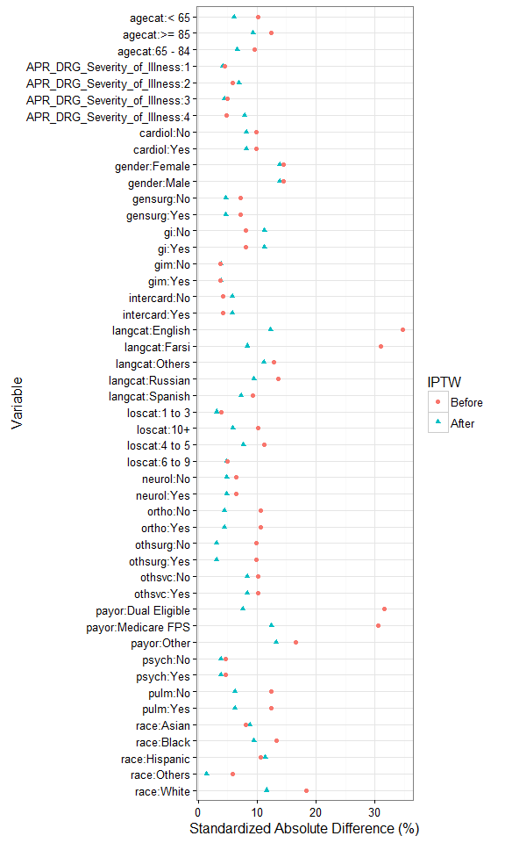

SUPPLEMENT REFERENCES
- R Core Team (2016). R: A language and environment for statistical computing. R Foundation for Statistical Computing, Vienna, Austria.
URL https://www.R-project.org/
- Li F, Zaslavsky AM, Landrum MB. Propensity score weighting with multilevel data. Statistics in Medicine 2013; 32: 3373-3387.
- Austin PC, Stuart EA. Moving towards best practice when using inverse probability of treatment weighting (IPTW) using the propensity score to estimate causal treatment effects in observational studies. Statistics in Medicine 2015; 34: 3661-3679.

