Appendix 1a: Individual site performance of key bronchiolitis QI measures over baseline, intervention and sustainability time periods.

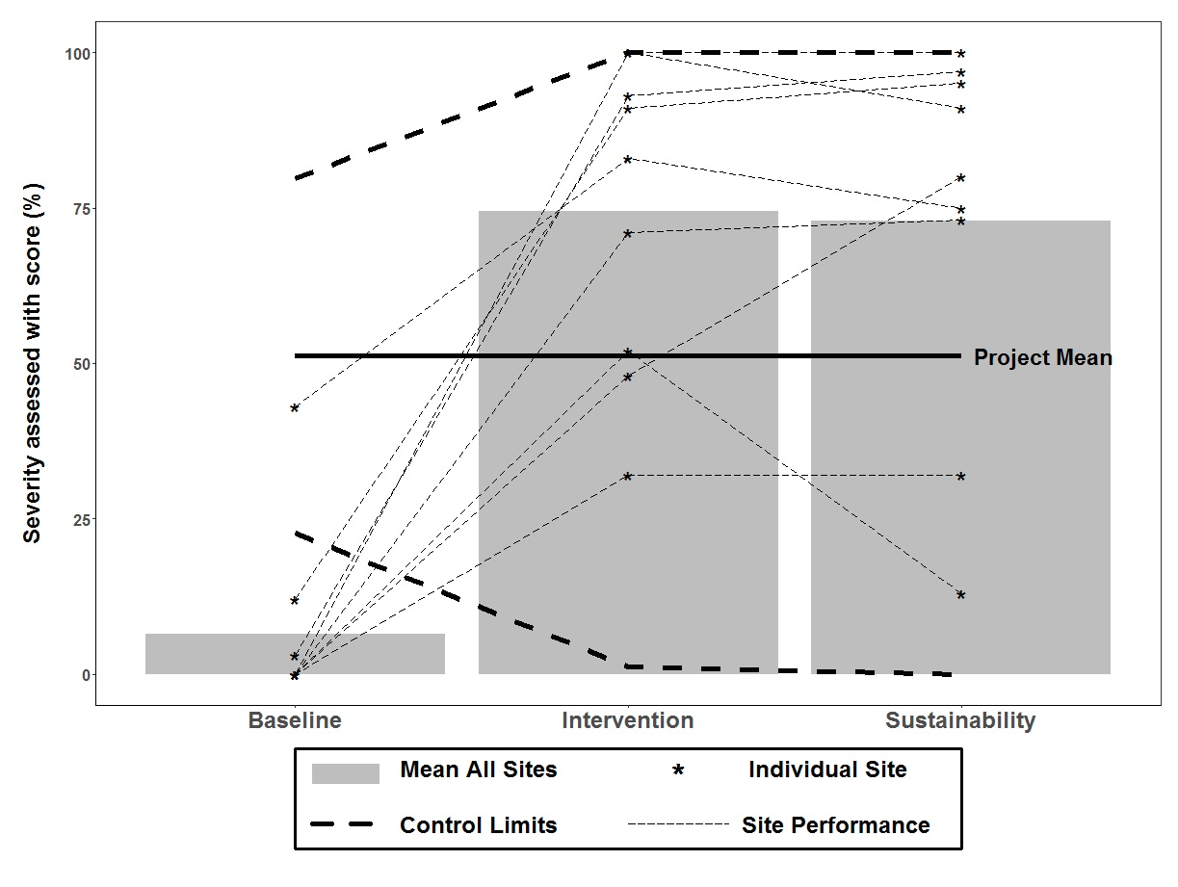
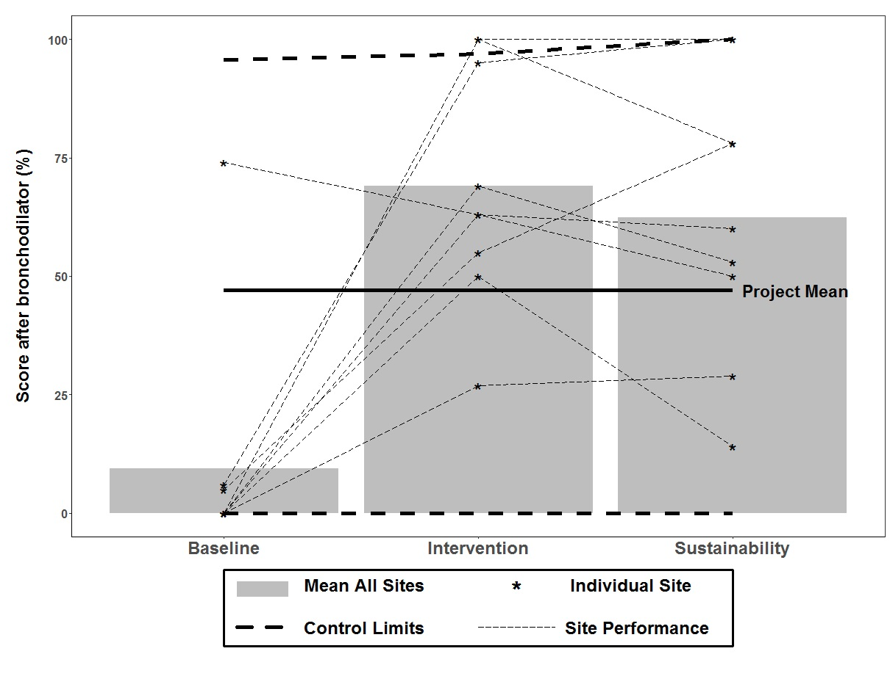
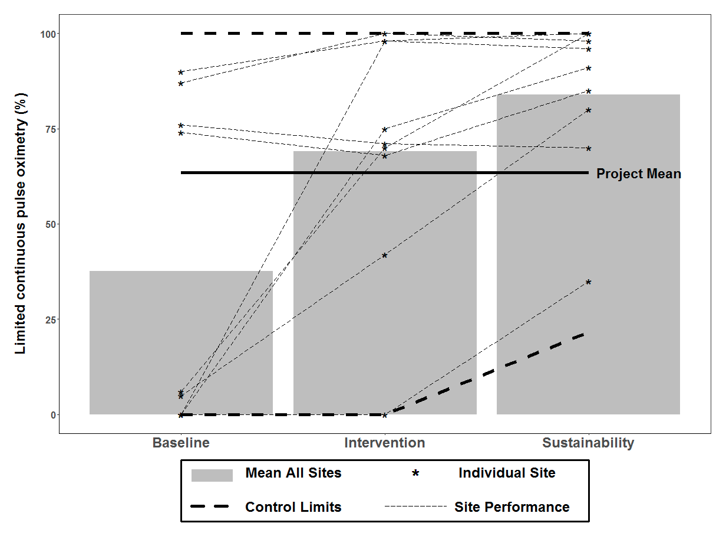
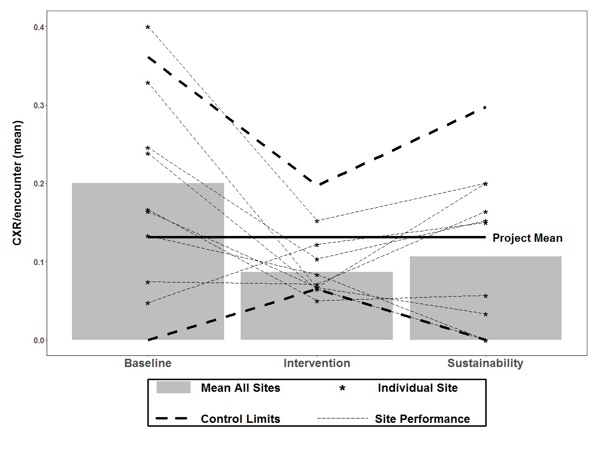
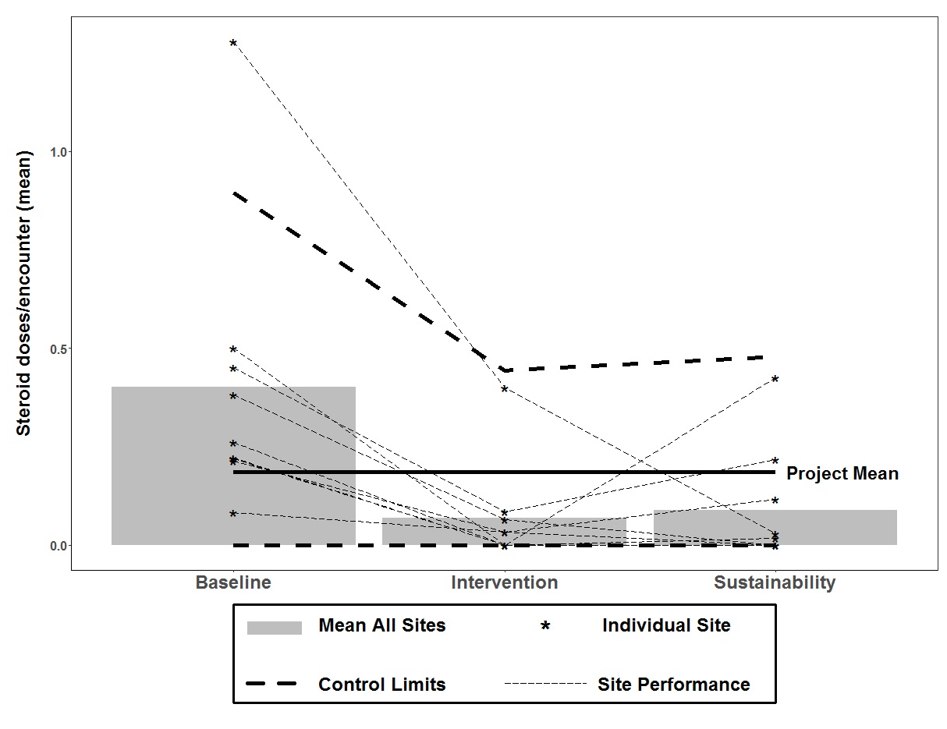
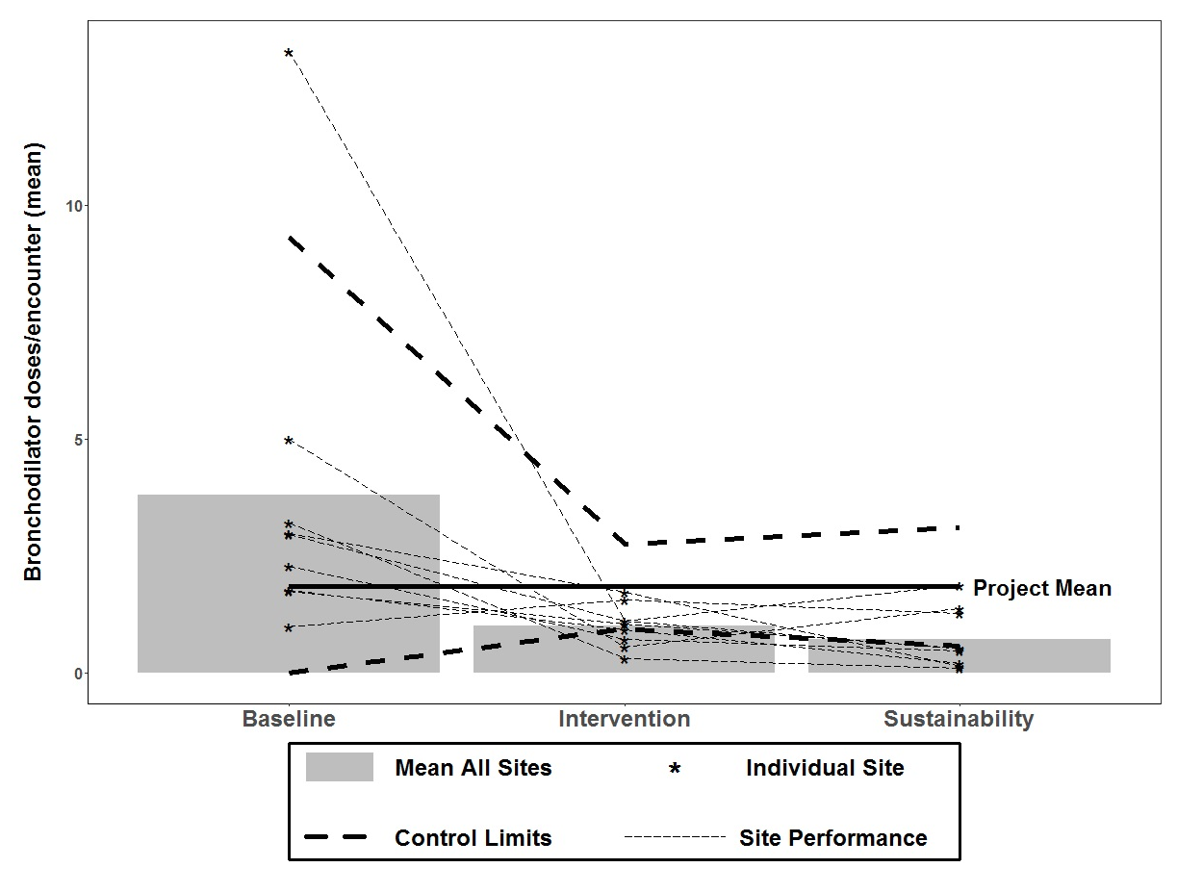
*Note control limits are 2 standard deviations from the project mean.

Appendix 1b: Differences in improvement in bronchiolitis quality measures from the baseline season to intervention season between sites that did and did not participate in the sustainability data collection season.

 | Sustainability site  OR | Non-Sustaining Site  OR | p-value
Severity assessed using respiratory score, % | 44.37 | 2.17 | <0.001
Respiratory score use to assess response to bronchodilator, % | 24.63 | 2.25 | 0.02
Bronchodilator use, % | 0.35 | 0.76 | 0.10
Bronchodilator doses/encounter, mean | -2.09 | -1.72 | 0.14
Steroids doses/encounter, mean | -0.29 | -0.19 | 0.52
Chest Radiograph/encounter, mean | -0.10 | -0.02 | 0.04
Presence of an order to transition to intermittent pulse oximetry, % | 3.30 | 2.35 | 0.50

