APPENDIX
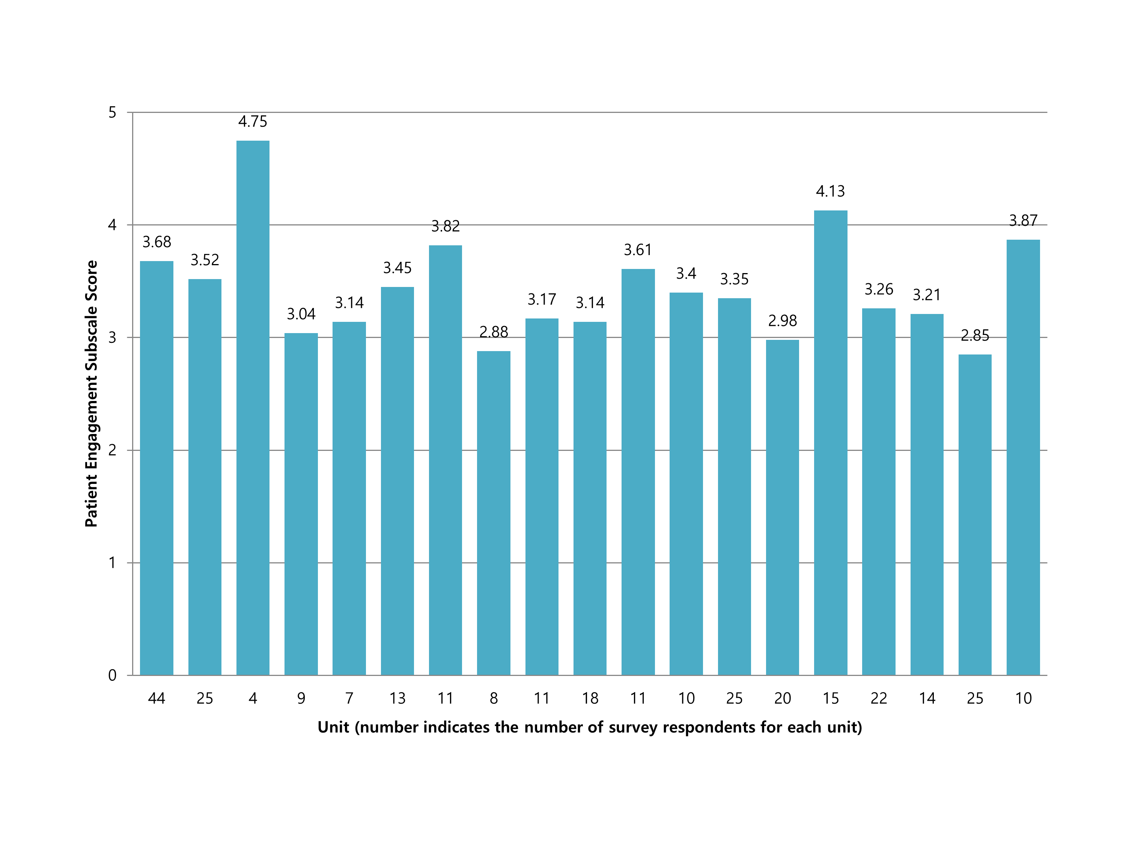
Caption: Fig 2. Differences in Patient Engagement subscale scores among 19 different JHH nursing units.

Patient engage subscale score ranges from 1 to 5. Numbers above each bar indicates the score of the unit. Higher scores indicate better care coordination. P-values are not calculated due to the small numbers of subjects in each unit.

Care Coordination Survey 2015 (with Care Coordination Atlas domains and broad approaches written below each item)
In this survey, think of your “work setting” as the unit, department, or clinical area of the hospital where you spend most of your work time, or provide most of your clinical services. Please complete this survey with respect to this SINGLE work setting.
Please indicate how much you agree or disagree with the statements below. If your role on the team does not allow you to answer a question, please answer “NA” (not applicable).
- In my work setting…
 | Disagree strongly | Disagree some-  what | Neutral | Agree some-  what | Agree  strongly | NA
Multidisciplinary rounds help to improve care coordination. (Teamwork)
Members of the health care team share information that enables timely decision-making. (Communication among team members)
Our clinical leader alerts the health care team about situations that may affect patient care. (Communication among team members)
Members of the health care team meet to reevaluate the patient care plan when the patient’s situation has changed. (Monitoring, following up and responding to change)
The health care team uses input from multidisciplinary rounds to help determine the patient’s care plan. (Assessing needs and goals)
The health care team explains information to patients and their families in lay terms. (Communication with patients)
My discipline has a clear protocol for sharing information during patient hand-offs. (Facilitating transitions)
The patient and/or family know who the primary contact is on their health care team. (Establishing accountability)
Patients are actively engaged in developing their plan of care. (Creating a proactive plan of care)
Patients are actively engaged in developing their discharge plans. (Creating a proactive plan of care)
Members of the health care team teach patients how to take care of themselves after they leave the hospital. (Supporting self-management goals)
The health care team gives patients the tools they need for a safe transition from the hospital to home, or the next care setting. (Supporting self-management goals)
NA=Not applicable
- Overall, how would you rate the care coordination at the hospital of your primary work setting (Johns Hopkins Hospital or Johns Hopkins Bayview)?
- 1 (Totally uncoordinated care)
- 2
- 3
- 4
- 5
- 6
- 7
- 8
- 9
- 10 (Perfectly coordinated care)
- With which hospital are you primarily affiliated? [List of hospitals provided]
- Which of the following units would you describe as your primary work setting (where you spend most of your work time, or provide most of your clinical services)? [List of nursing units provided]
- Primary Department [List of departments provided]
- Position [List of positions provided]
- Total years in specialty
- Additional comments

