Electronic Appendices

Appendix Table 1. List of Enrolling Sites
Oregon Heath & Science University, Portland, OR
University of California, Davis School of Medicine, Sacramento, CA
University of Rochester, NY
William Beaumont Hospital-Troy, Troy, MI
William Beaumont Hospital-Royal Oak, Royal Oak, MI
Brigham & Women's Hospital, Boston, MA
The Ohio State University Wexner Medical Center, Columbus, OH
Thomas Jefferson University Hospital, Philadelphia, PA
Wake Forest School of Medicine, Winston Salem, NC
Summa Health System, Akron, OH
Vanderbilt University, Nashville, TN

Appendix Table 2. Characteristics of older adults with syncope with and without transthoracic echocardiography obtained
Variable | All Syncope Patients (N=3686)  No. (%) | No TTE Obtained (N=2691) No. (%) | TTE Obtained (N=995) No. (%) | p-value
Age (mean) SD | 72.74 (8.98) | 72.23 (8.87) | 74.13 (9.12) | <0.001
Male Gender | 1900 (51.5) | 1353 (50.3) | 547 (55.0) | 0.013
Race |  |  |  | 0.445
White | 3050 (83.2) | 2237 (83.7) | 813 (82.0)
Black | 500 (13.6) | 354 (13.2) | 146 (14.7)
Other | 114 (3.1) | 81 (3.0) | 33 (3.3)
Abnormal heart sounds | 356 (9.8) | 223 (8.4) | 133 (13.5) | <0.001
Exertional syncope | 682 (18.6) | 488 (18.2) | 194 (19.6) | 0.368
Shortness of breath | 770 (21.4) | 557 (21.2) | 213 (21.9) | 0.674
Chest discomfort | 325 (9.0) | 239 (9.0) | 86 (8.9) | 0.912
Near syncope | 1424 (38.6) | 1128 (41.9) | 296 (29.7) | <0.001
SBP over 180 mmHg | 35 (1.0) | 25 (0.9) | 10 (1.0) | 0.981
SBP under 90 mmHg | 143 (3.9) | 101 (3.8) | 42 (4.2) | 0.595
History of SCD in 1st degree relative | 389 (10.6) | 294 (11.0) | 95 (9.6) | 0.235
History of hypertension | 2436 (66.1) | 1753 (65.2) | 683 (68.8) | 0.044
History of dysrhythmia | 823 (22.3) | 573 (21.3) | 250 (25.2) | 0.014
History of renal failure | 415 (11.3) | 296 (11.0) | 119 (12.0) | 0.438
History of diabetes | 904 (24.5) | 638 (23.7) | 266 (26.8) | 0.06
History of CHF | 469 (12.7) | 316 (11.7) | 153 (15.4) | 0.004
History of CAD | 1017 (27.6) | 713 (26.5) | 304 (30.6) | 0.015
Abnormal ECG | 2007 (55.5) | 1396 (53.0) | 611 (62.2) | <0.001
Hs-TnT over  14 picogram/ml | 1460 (42.9) | 981 (39.5) | 479 (52.1) | <0.001
NT-proBNP over  125 pg/ml | 2318 (66.2) | 1620 (63.4) | 698 (73.6) | <0.001

TTE: Transthoracic Echocardiography. SD: Standard deviation. SBP: Systolic Blood Pressure. mmHg: millimeters of mercury. SCD: Sudden Cardiac Death. CHF: Congestive Heart Failure. CAD: Coronary Artery Disease. ECG: Electrocardiogram. NT-proBNP: N-terminal pro B-type natriuretic peptide. Hs-TnT: high-sensitivity cardiac troponin T.

Appendix Figure 1. Probability of Major Findings on Transthoracic Echocardiography as a Function of Number of High-Risk Clinical Variables

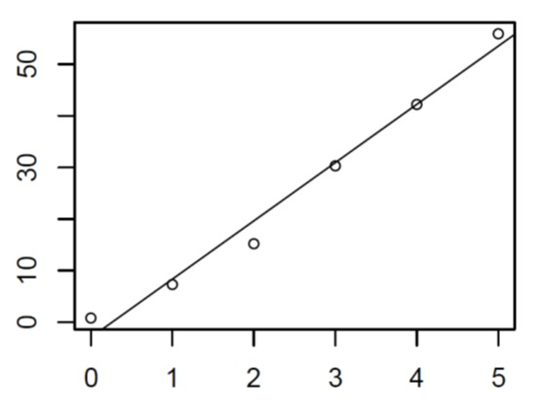
% of Patients with Major Findings on TTE
ROMEO Score

TTE: Transthoracic Echocardiography.
Appendix Figure 2. Receiver operating characteristic curve of the ROMEO criteria for clinically significant findings on transthoracic echocardiography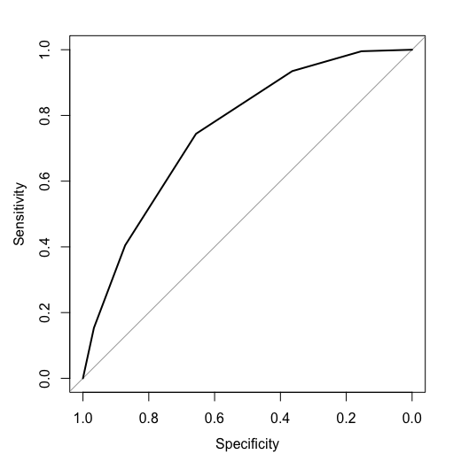
ROMEO: Risk Of Major Echocardiography findings in Older adults with syncope.
Area Under the Curve, mean (95% CI): 0.755 (0.72, 0.79). Confidence interval obtained through 2000 stratified bootstrap replicates.

Appendix Table 3: Probability of Major Findings on Echocardiography by number of predictors
Number of Predictors | Major Finding on TTE | No Major Finding on TTE | Percent (95% CI)
0 | 1 | 120 | 0.8 (.02, 4.5)
1 | 13 | 164 | 7.3 (4.0, 12.2)
2 | 41 | 228 | 15.2 (11.2, 20.1)
3 | 73 | 168 | 30.3 (24.6, 36.5)
4 | 54 | 74 | 42.2 (33.5, 51.2)
5 | 33 | 26 | 55.9 (42.4, 68.9)
Total: | 215 | 780
TTE: Transthoracic Echocardiography. CI: Confidence intervals (calculated using binomial method).

Appendix Table 4. Frequency of missing data by variable, n=139
Variable | No. (%)
Age | 0 (0.0)
Abnormal heart sounds | 11 (1.1)
Exertional syncope | 6 (0.6)
History of CHF | 2 (0.2)
History of CAD | 2 (0.2)
Abnormal ECG | 13 (1.3)
Hs-TnT >14 pg/ml | 76 (7.6)
NT-proBNP>125 pg/ml | 47 (4.7)
Male Gender | 0 (0.0)
Shortness of breath | 23 (2.3)
Chest pain | 24 (2.4)
Near syncope | 0 (0.0)
Family history of SCD | 2 (0.2)
SBP > 180 mmHg | 4 (0.4)
SBP < 90 mmHg | 3 (0.3)
History of hypertension | 2 (0.2)
History of dysrhythmia | 2 (0.2)
History of renal failure | 2 (0.2)
History of diabetes | 2 (0.2)

CHF: Congestive Heart Failure. CAD: Coronary Artery Disease. ECG: Electrocardiogram. Hs-TnT: high-sensitivity cardiac troponin T. NT-proBNP: N-terminal pro B-type natriuretic peptide. SCD: Sudden Cardiac Death. SBP: Systolic Blood Pressure.

Appendix Table 5. LASSO Model Selection Results using Troponin > 30 pg/ml
Variable | OR | 95% CI | P(OR<1) | P(OR=1) | P(OR>1)
Age | 1.00 | (1.00, 1.00) | 0.012 | 0.978 | 0.010
Abnormal heart sounds | 1.00 | (1.00, 1.53) | 0.000 | 0.643 | 0.357
Exertional syncope | 1.00 | (1.00, 1.28) | 0.000 | 0.803 | 0.197
History of CHF | 1.75 | (1.04, 2.69) | 0.000 | 0.018 | 0.982
History of CAD | 1.38 | (1.00, 2.00) | 0.000 | 0.085 | 0.915
Abnormal ECG | 1.81 | (1.17, 2.63) | 0.000 | 0.002 | 0.998
Hs-TnT >30 pg/ml | 1.45 | (1.00, 2.06) | 0.000 | 0.069 | 0.931
NT-proBNP >125 pg/ml | 1.66 | (1.03, 2.58) | 0.000 | 0.015 | 0.985
Male Gender | 1.00 | (1.00, 1.45) | 0.000 | 0.542 | 0.458
Shortness of breath | 1.10 | (1.00, 1.60) | 0.000 | 0.411 | 0.589
Chest pain | 1.00 | (1.00, 1.13) | 0.005 | 0.955 | 0.040
Near syncope | 1.00 | (1.00, 1.39) | 0.000 | 0.643 | 0.357
Family history of SCD | 1.00 | (1.00, 2.03) | 0.001 | 0.885 | 0.114
SBP > 180 mmHg | 1.00 | (0.79, 1.00) | 0.088 | 0.912 | 0.000
SBP < 90 mmHg | 1.00 | (1.00, 1.53) | 0.000 | 0.704 | 0.296
History of hypertension | 1.00 | (1.00, 1.00) | 0.002 | 0.980 | 0.018
History of dysrhythmia | 1.00 | (1.00, 1.17) | 0.000 | 0.904 | 0.096
History of renal failure | 1.00 | (1.00, 1.00) | 0.004 | 0.981 | 0.015
History of diabetes | 1.00 | (1.00, 1.12) | 0.001 | 0.914 | 0.085

CI: Confidence Interval. OR: Odds Ratio. CHF: Congestive Heart Failure. CAD: Coronary Artery Disease. ECG: Electrocardiogram. NT-proBNP: N-terminal pro B-type natriuretic peptide. Hs-TnT: high-sensitivity cardiac troponin T. SCD: Sudden Cardiac Death. SBP: Systolic Blood Pressure.

