Appendix Figure. Diagnosis-Specific Seven-Day Risk Adjusted PPR and AC rates over time
Conditions with a high percentage of AC readmissions classified as PPR are displayed in panels A-F:
A. appendectomy (APR-DRG 225), connective tissue disorders (APR-DRG 346), ventricular shunt procedures (APR-DRG 22), bronchiolitis (APR-DRG 138), asthma (APR-DRG 141), and sickle cell crisis (APR-DRG 662)
Conditions with a low percentage of AC readmissions classified as PPR are displayed in panels G-I:
G. gastrointestinal infections (APR-DRG 248), hematologic disease (APR-DRG 660), and bone marrow transplant(APR-DRG 3)

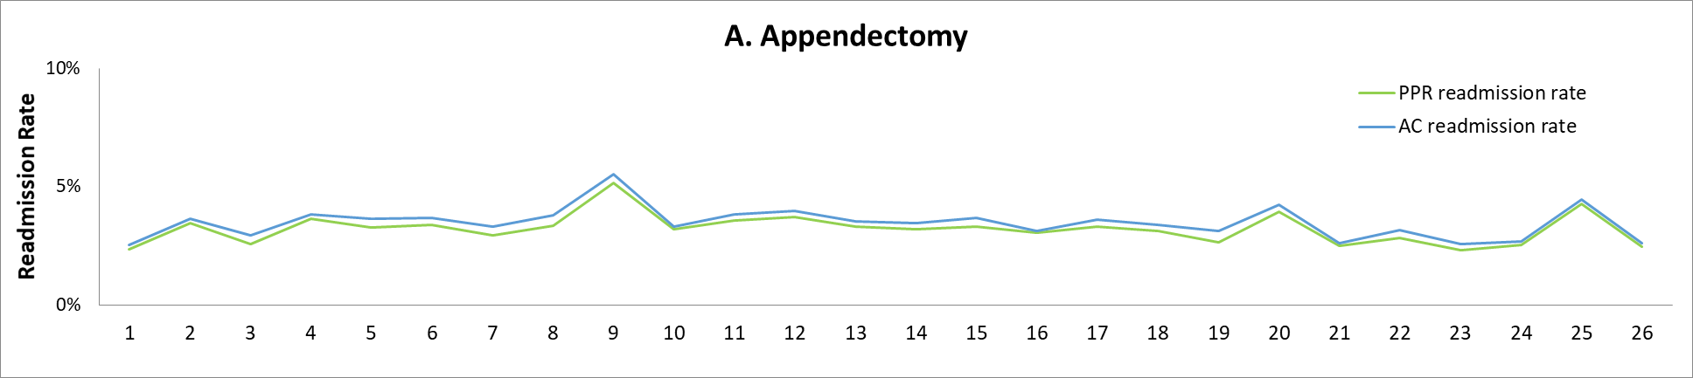
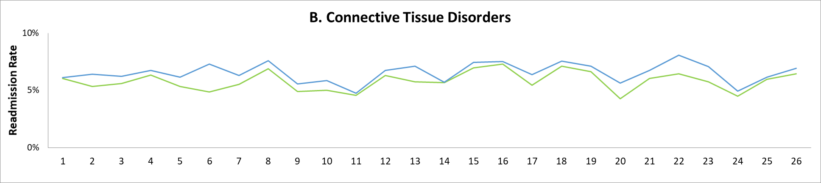
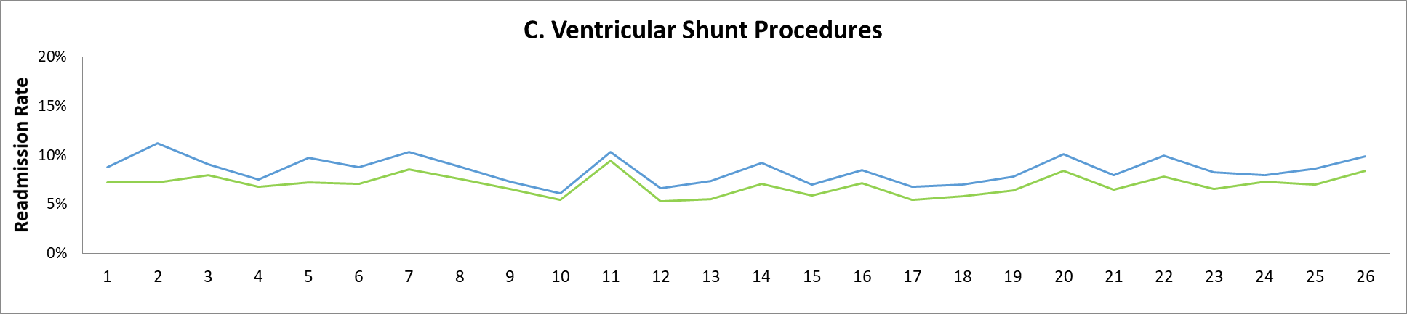
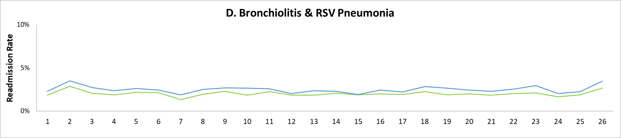
Quarter Number

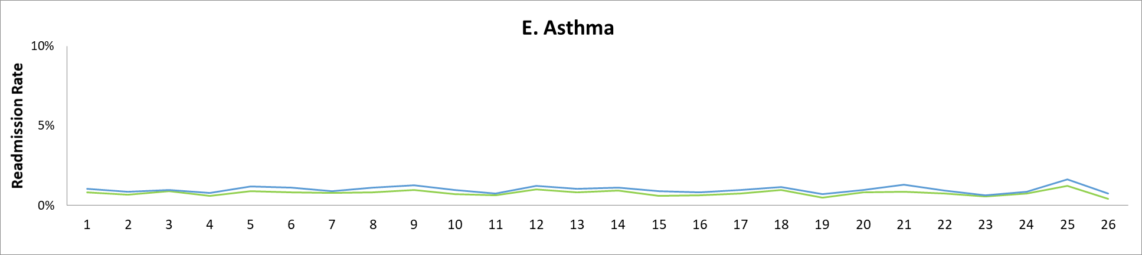
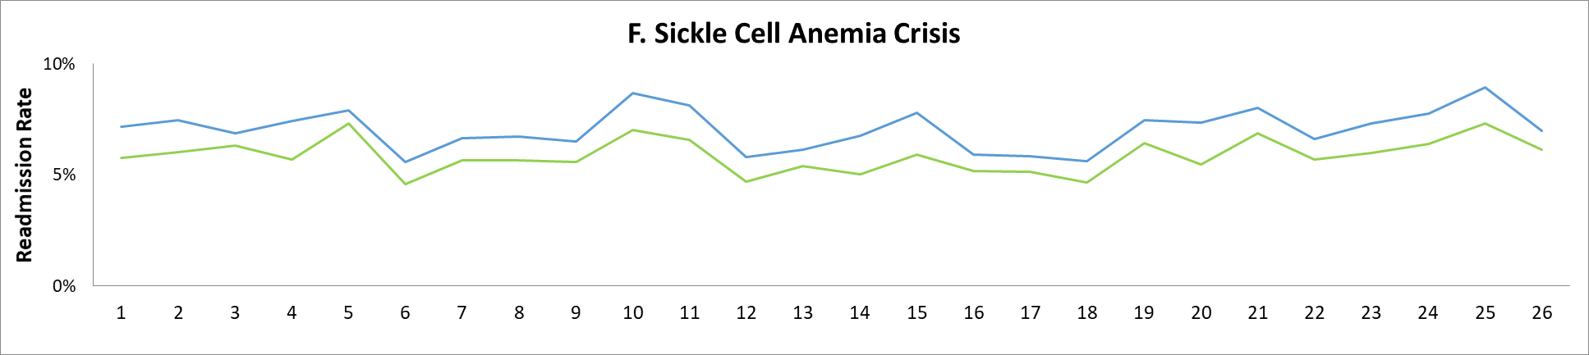
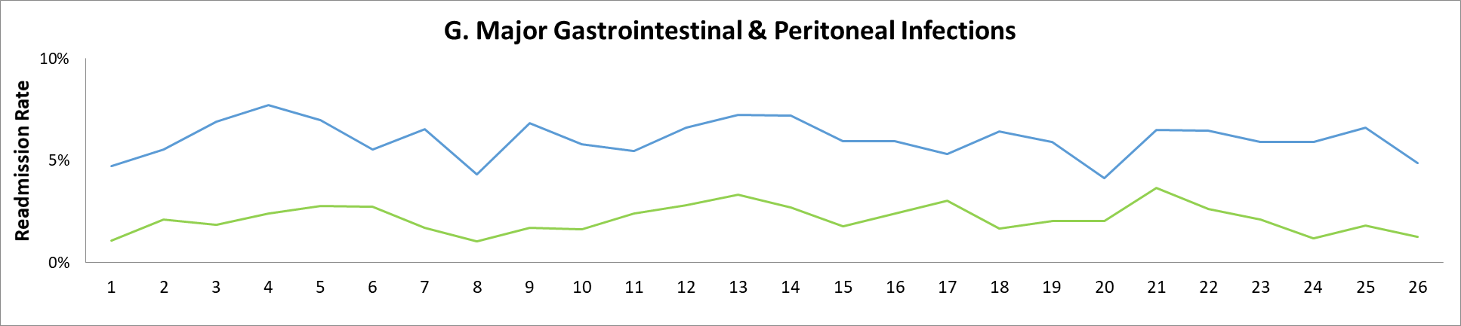
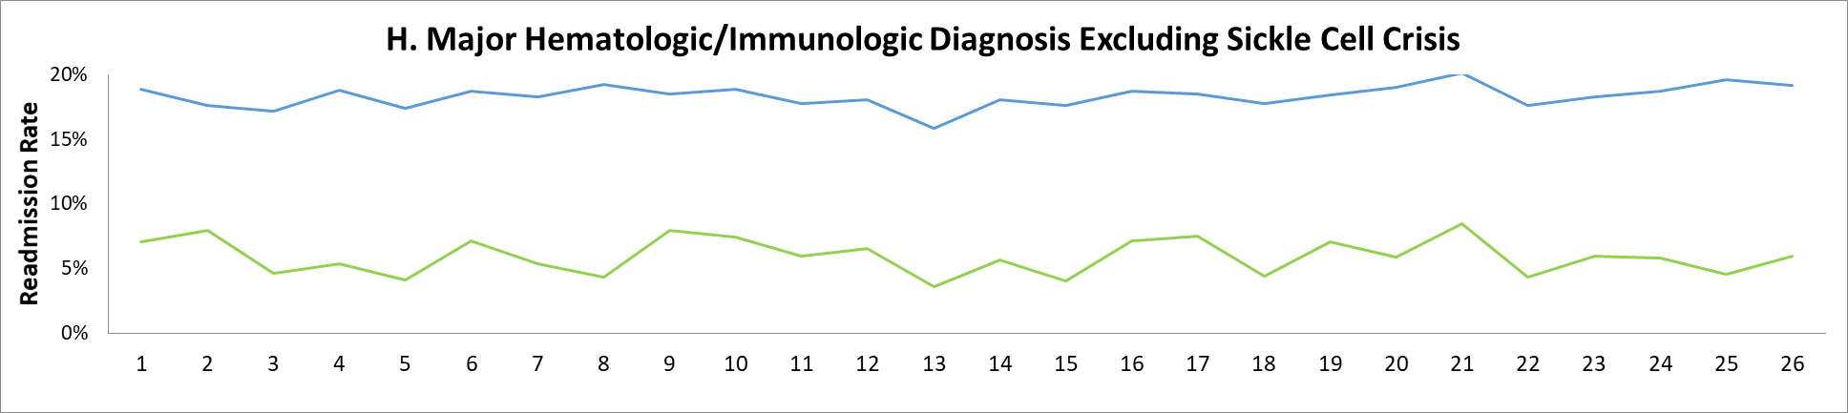
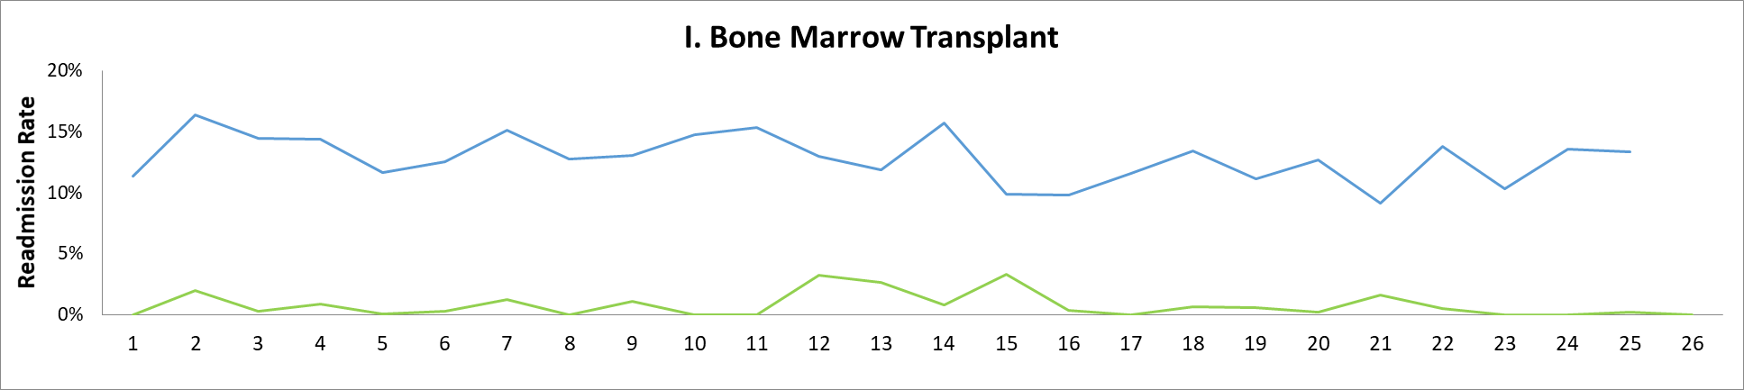
Quarter Number

Appendix Table 1: Hospital Characteristics (n = 66 hospitals)

Characteristics | Number (%)
Hospital size
<100 beds | 4 (6.1)
100-299 beds | 42 (63.6)
≥300 beds | 20 (30.3)
Freestanding Children’s Hospital | 41 (62.1)
Geographic Region
Northeast | 11 (16.7)
South | 27 (40.9)
Midwest | 16 (24.2)
West | 12 (18.2)
Magnet Nursing Designation | 44 (66.7)

Appendix Table 2: Patient Characteristics for Cohort by Year

 | 2010 | 2011 | 2012 | 2013 | 2014 | 2015 | 2016* | P value for change over time
Hospital Admissions | 679,648 | 688,708 | 693,237 | 694,993 | 698,650 | 705,604 | 357,406 | 0.99
% Neonate | 12% | 12% | 13% | 13% | 14% | 14% | 14% | 0.47
Race/Ethnicity
White | 49% | 49% | 48% | 48% | 48% | 47% | 47% | 0.95
Black | 20% | 20% | 18% | 19% | 19% | 19% | 18% | 0.99
Hispanic | 19% | 19% | 18% | 19% | 20% | 20% | 20% | 0.99
Other | 12% | 12% | 16% | 14% | 14% | 14% | 15% | 0.54
% Medicaid Insurance | 47% | 49% | 49% | 50% | 51% | 51% | 51% | 0.79
Average Case Mix Index | 2.66 | 2.67 | 2.69 | 2.78 | 2.85 | 2.93 | 2.94 | 0.04
*First two quarters

