Appendix 1: Prevalence of gabapentinoid pre-admission use from December 2013 to July 2017ª

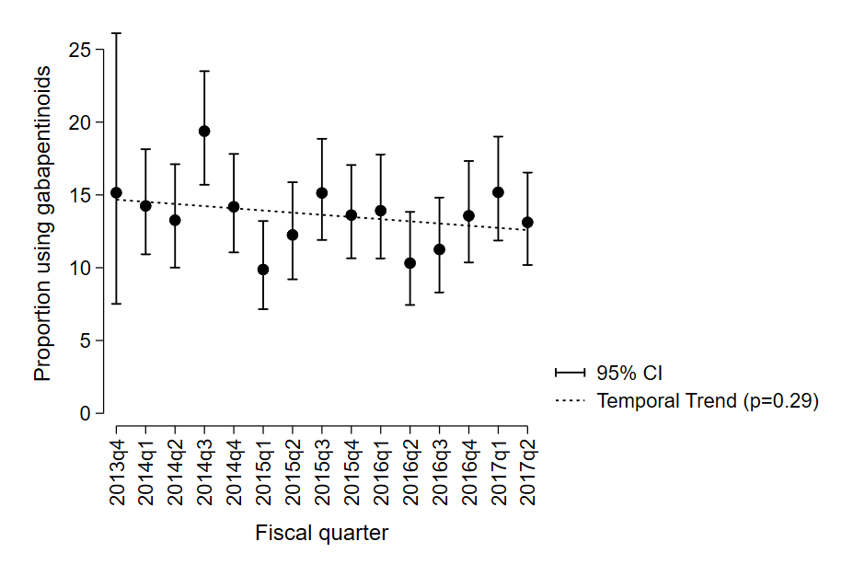

ªJanuary to March = q1; April to June = q2; July to September = q3; October to December = q4.

Appendix 2: Indications for new gabapentinoid prescriptions at dischargeª

 | Total  N=48^{b} | Gabapentin  N=11 | Pregabalin  N=37
Indications
Neuropathic pain disorders
Neuropathic pain, not otherwise specified | 18 (37.5) | 3 (27.3) | 15 (40.5)
Diabetic Neuropathic Pain | 4 (8.3) | 1 (9.1) | 3 (8.1)
Postherpetic neuralgia | 4 (8.3) | 1 (9.1) | 3 (8.1)
Spinal cord injury neuropathic pain | 0 (0) | 0 (0) | 0 (0)
Musculoskeletal and other nociceptive pain disorders
Musculoskeletal pain | 8 (16.7) | 2 (18.2) | 6 (16.2)
Cancer-associated pain | 6 (12.5) | 2 (18.2) | 4 (10.8)
Other
Not specified | 3 (6.3) | 0 (0) | 3 (8.1)
Diabetes mellitus, neuropathic pain not documented | 3 (6.3) | 0 (0) | 3 (8.1)
Alcohol use disorder | 2 (4.2) | 2 (18.2) | 0 (0)
Total | 48 (100) | 11 (100) | 37 (100)

ªAll data are given as number (percentage) unless otherwise indicated
^{b}Total of 48 patients includes 3 patients for whom there was a gabapentinoid class change at discharge

Appendix 3. Indication for gabapentinoid deprescribing at discharge among pre-admission usersª

Indication for discontinuation (N=69^{b}) | No. (%)
Adverse drug reaction | 15 (21.7)
Absence of indication | 6 (8.7)
Change to another gabapentinoid or duplication of therapy^{b} | 4 (5.8)
Being tapered prior to admission | 2 (2.9)
Absence of efficacy | 1 (1.4)
Other | 3 (4.3)
Unknown/reason for discontinuation not documented | 38 (55.1)
Total | 69 (100)

ªAll data are given as number (percentage) unless otherwise indicated
^{b} Total of 69 patients includes 3 patients for whom there was a gabapentinoid class change at discharge and 1 patient who was taking 2 gabapentinoids pre-admission, with only 1 continued at discharge.

Appendix 4. Prevalence of gabapentinoid deprescribing among pre-admission users from December 2013 to July 2017ª

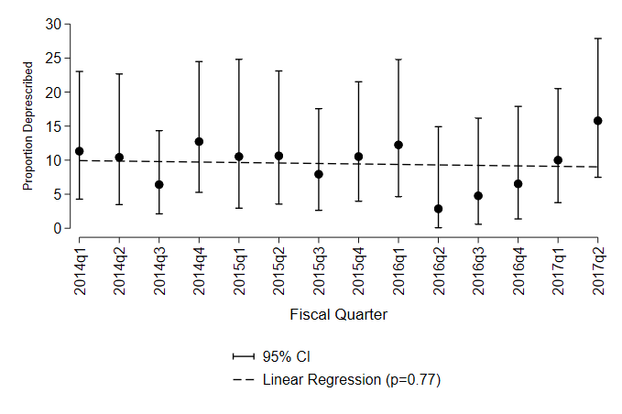

ªJanuary to March = q1; April to June = q2; July to September = q3; October to December = q4. Excludes patients who died during admission.

