Appendix Figure. Overlapping Patient Episodes between Medicare ACO and Bundled Payment Participants
Panel A. Overlap facing ACOs-the percentage of ACO-attributed patients who received care at bundled payment hospitals.
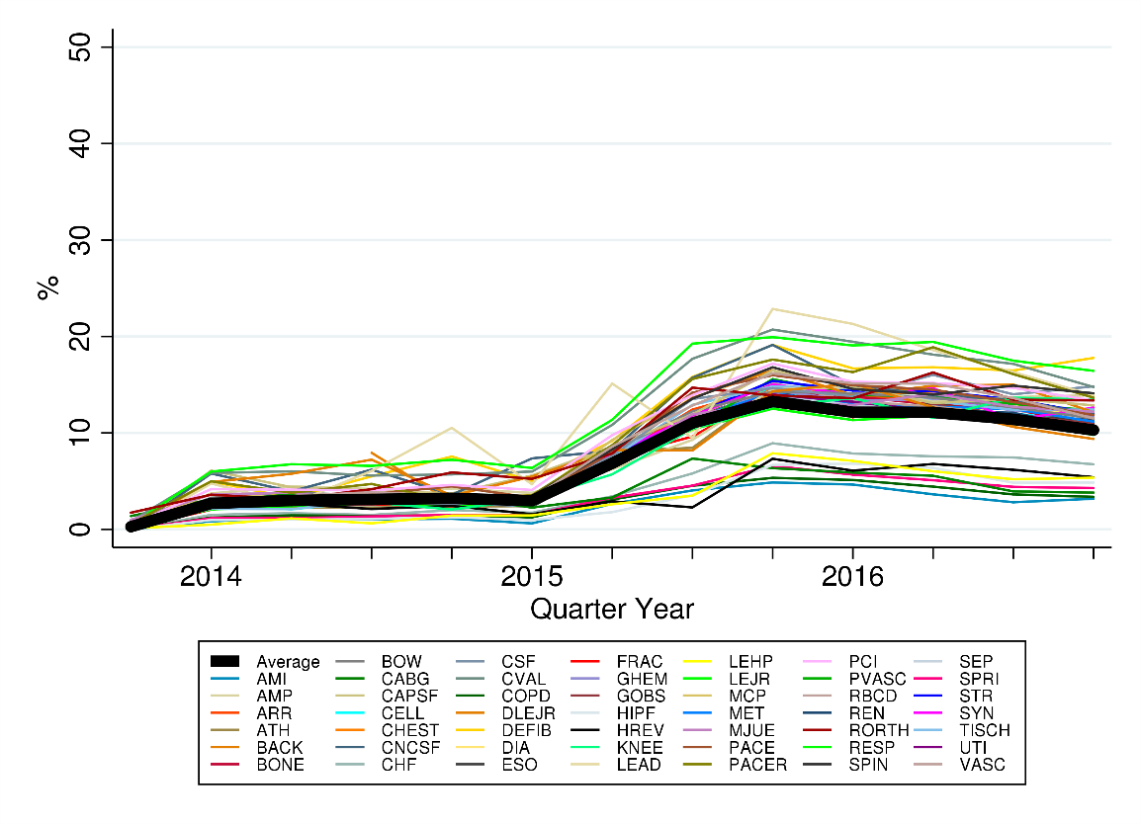
Panel B. Overlap facing bundled payment hospitals-the percentage of patients receiving care at bundled payment hospitals who were attributed to ACOs.
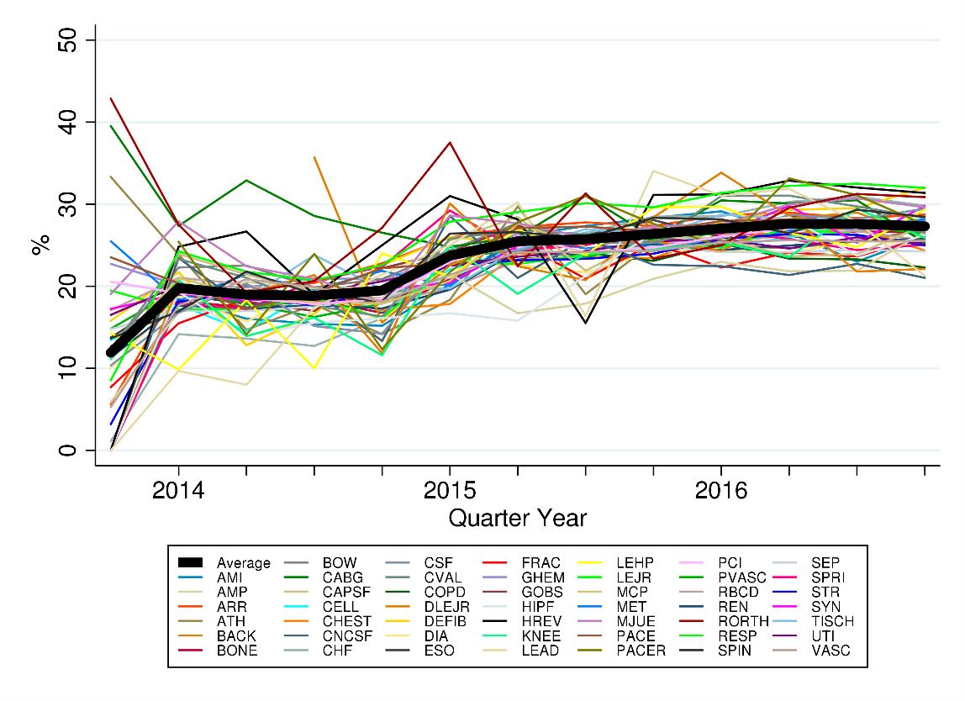
Legend: Figure. Overlapping Patient Episodes between Medicare ACO and Bundled Payment Participants
Panel A. Overlap facing ACOs-the percentage of ACO-attributed patients who received care at bundled payment hospitals. Panel A illustrates overlap by plotting the percentage of MSSP ACO patients receiving care from BPCI participant hospitals for 1 of 48 included episodes.
Panel B. Overlap facing bundled payment hospitals-the percentage of patients receiving care at bundled payment hospitals who were attributed to ACOs. Panel B illustrates overlap by plotting the percentage of patients receiving care from BPCI participant hospitals for 1 of 48 included episodes who were also attributed to MSSP ACOs.
ABBREVIATIONS: AMI: acute myocardial infarction; AMP: amputation; ARR: cardiac arrhythmia; ATH: atherosclerosis; BACK: back and neck except spinal fusion; BONE: medical noninfectious orthopedic; BOW: major bowel; CABG: coronary artery bypass graft surgery; CAPSF: combined anterior-posterior spinal fusion; CELL: cellulitis; CHEST: chest pain; CNCSF: complex noncervical spinal fusion; CHF: congestive heart failure; CSF: cervical spinal fusion; CVAL: cardiac valve; COPD: chronic obstructive pulmonary disease, bronchitis/asthma; DLEJR: double joint replacement of the lower extremity; DEFIB: cardiac defibrillator; DIA: diabetes; ESO: esophagitis, gastroenteritis, and other digestive disorders; FRAC: fractures of the femur and hip/pelvis; GHEM: gastrointestinal hemorrhage; GOBS: gastrointestinal obstruction; HIPF: hip and femur procedures except major joint; HREV: revision of the hip or knee; KNEE: other knee procedures; LEAD: automatic implantable cardiac defibrillator generator or lead; LEHP: lower extremity and humerus procedure except hip, foot, femur; LEJR: major joint replacement of the lower extremity; MCP: major cardiovascular procedure; MET: nutritional and metabolic disorders; MJUE: major joint upper extremity; PACE: pacemaker; PACER: pacemaker device replacement or revision; PCI: percutaneous coronary intervention; PVASC: medical peripheral vascular disorders; RBCD: red blood cell disorders; REN: renal failure; RORTH: removal of orthopedic devices; RESP: other respiratory; SPIN: spinal fusion (noncervical); SEP: sepsis; SPRI: simple pneumonia and respiratory infections; SYN: syncope and collapse; TISCH: transient ischemia; UTI: urinary tract infection; VASC: other vascular surgery.

