Appendix Figure 1. Case Selection Flow Chart
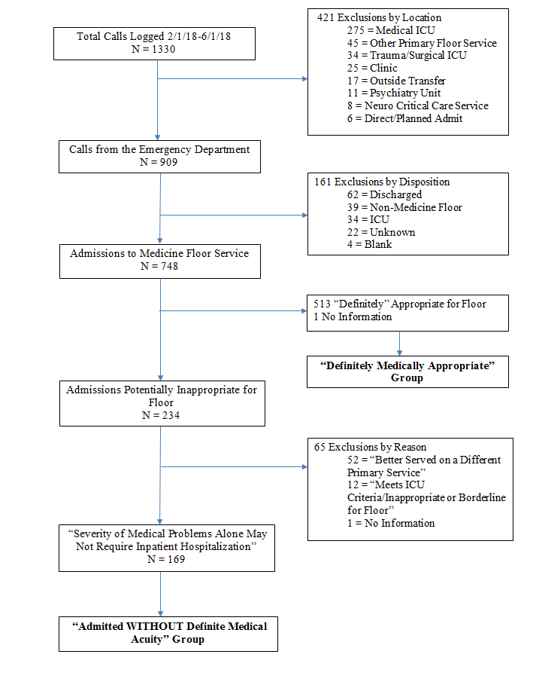
Appendix Table 1. Reason for Admission per Triage Physician
 | Admitted Without Definite Medical Acuity  n = 150 | Definitely Medically Appropriate Admission  n = 150
Diagnoses/Syndromes | 80 (53%) | 99 (66%)
Infectious Disease | 34  Cellulitis (21), pneumonia (7), abscess (2), influenza (1), UTI (1), tetanus (1), shivering/concern for infection (1) | 42  Cellulitis (12), pneumonia (7), sepsis NOS (6), pyelonephritis (4), abscess (3), facial rash w/ocular involvement (3), osteomyelitis (1), empyema (1), cholangitis (1), gangrene (1), CMV retinitis (1), influenza (1), septic arthritis (1)
Gastrointestinal | 9  GI bleed (4), esophagitis (1), chronic pancreatitis (1), gastroparesis (1), gastroenteritis (1) clogged feeding tube (1) | 18  GI bleed (6), decompensated cirrhosis (4), foreign body/food impaction (3), acute liver failure (2), IBD flare (2), acute pancreatitis (1)
Renal | 8  Missed chronic dialysis (8) | 9  Acute renal failure (6), rhabomyolysis (1), nephrotic syndrome (1), clotted AV fistula (1)
Substance Overdose or Withdrawal | 9 | 8
Pulmonary | 6  COPD (3), pulmonary hypertension (1), aspiration (1), smoke inhalation (1) | 5  COPD (3), hemoptysis (1), cavitary lesion (1)
Dermatologic | 6  Non-healing wounds (5), rash (1) | 0
Hematologic/Oncologic | 3  DVT (1), RUL Mass/new diagnosis (1), symptomatic brain metastases (1) | 4  Large SVC clot (1), severe dysphagia/esophageal malignancy (1), symptomatic metastatic malignancy (1), radiation cystitis/osteonecrosis (1)
Neurologic | 1  Facial droop (1) | 3  Rule out stroke (1), dizziness/vertigo (2)
Diabetic Ketoacidosis | 0 | 2
Psychiatric | 1  Anxiety (1) | 2  Suicide attempt (2)
Ophthalmologic | 0 | 1  Retinal detachment (1)
Cardiac | 1  CHF exacerbation (1) | 1  CHF exacerbation (1)
Orthopedic | 2  Subacute/nonoperative fracture (2) | 4  Acute fracture after fall (4)
Undifferentiated Symptoms | 52 (34.7%) | 36 (24%)
Pain | 15  Back (4), head (2), abdominal (2), general/chronic (2), knee (1), hip (1), leg (1), hand (1), testicular (1) | 12  Abdominal (5), leg (3), back (1), shoulder (1), chest (1), hand (1)
Ambulatory dysfunction or weakness | 17 | 2
Altered Mental Status | 7 | 7
Swelling | 3  Lower extremity edema (2), abdominal distention (1) | 5  Arm/hand (3), face (1), parotid glands (1)
Dyspnea | 3 | 2
Syncope | 0 | 4
Nausea/vomiting | 2 | 2
Diarrhea/constipation | 2 | 2
Malaise/fatigue | 3 | 0
Objective Measurements | 4 (2.7%) | 13 (8.7%)
Abnormal Laboratory Values | 2  Anemia (1), hyponatremia (1) | 6  Hyponatremia (2), elevated lactate (1), anemia (1), thrombocytopenia (1), hypokalemia (1)
Abnormal Vital Signs | 2  Orthostatic hypotension (1), hypotension at dialysis (1) | 7  Hypotension (3), tachycardia/arrhythmia (2), hypoxia (1), hypertension (1)
Other/Disposition | 9 (6%) | 2 (1.3%)
Other Reason for Admission | 9  “Failure to thrive” (4), discharged from SNF (3), “needs placement” (2) | 2  “Medical optimization” (1), elder abuse (1)
Reason Not Listed | 5 (3.3%) | 0 (0%)
X²(4, N = 300) = 16.8, p = 0.002
Appendix Table 2. Factors Contributing to the Decision to Admit Patients Without Definite Medical Acuity per Triage Physician
Factor | # of Cases in which Factor Contributed to Decision to Admit (%)
Homelessness | 51 (34)
Lack of Outpatient Social Support | 48 (32)
Substance Use Disorder | 38 (25)
Lack of Outpatient Medical Support | 30 (20)
Physical Limitation | 28 (19)
Mental Health Disorder | 22 (15)
Low Health Literacy | 19 (13)
Cognitive Limitation | 18 (12)
Non-English Speaker | 12 (8)
Skilled Nursing Facility or Adult Family Home Issue | 7 (5)
None of the Above | 13 (9)
Other | 32 (21)
Multiple responses could be selected. “Other” category included: lack of agreement between referring physician and Triage physician regarding comfort with discharge plan (15), lack of acceptance of patient to non-SNF/AFH facility such as jail, psychiatric facility, dialysis center (11), lack of available assessment in ED such as physical therapy or prosthetics (3), frequent healthcare utilization (2), adverse event encountered in ED prompted admission that otherwise was not needed (1)

Appendix Table 3. Positive Triggers Resulting in Identification of Adverse Events, By Level of Severity E-I and Admission Designation
 | Admitted Without Definite Medical Acuity |  |  |  |  | Definitely Medically Appropriate Admissions
 | Level E | Level F | Level G | Level H | Level I | Level E | Level F | Level G | Level H | Level I
Cares Module
C1: Transfusion of blood product | 0 | 0 | 0 | 0 | 0 | 1 | 1 | 0 | 0 | 0
C2: Code/arrest/Rapid Response activation | 8 | 1 | 0 | 0 | 1 | 6 | 0 | 0 | 0 | 0
C3: Acute dialysis | 0 | 0 | 0 | 1 | 0 | 0 | 0 | 0 | 0 | 0
C4: Positive blood culture | 0 | 0 | 0 | 0 | 0 | 1 | 0 | 0 | 0 | 0
C5: X-ray or Doppler for emboli or DVT | 0 | 0 | 0 | 1 | 0 | 0 | 0 | 0 | 0 | 0
C6: Decrease of greater than 25% in hemoglobin or hematocrit | 0 | 0 | 0 | 0 | 0 | 0 | 0 | 0 | 0 | 0
C7: Patient fall | 12 | 0 | 0 | 0 | 0 | 2 | 0 | 0 | 0 | 0
C8: Pressure ulcers | 0 | 0 | 0 | 0 | 0 | 0 | 0 | 0 | 0 | 0
C9: Readmission within 30 days | 0 | 0 | 0 | 0 | 0 | 0 | 0 | 0 | 0 | 0
C10: Restraint use | 0 | 0 | 0 | 0 | 0 | 2 | 0 | 0 | 0 | 0
C11: Healthcare associated infection | 0 | 1 | 0 | 0 | 0 | 0 | 0 | 0 | 0 | 0
C12: In-hospital stroke | 0 | 0 | 0 | 0 | 0 | 0 | 0 | 0 | 0 | 0
C13: Transfer to higher level of care | 0 | 4 | 0 | 0 | 1 | 1 | 2 | 0 | 0 | 1
C14: Any procedure complication | 4 | 5 | 0 | 0 | 0 | 7 | 3 | 0 | 1 | 0
C15: Other | 4 | 3 | 0 | 0 | 0 | 4 | 1 | 0 | 0 | 0
Medication Module
M1: Clostridium difficile positive stool | 0 | 0 | 0 | 0 | 0 | 0 | 0 | 0 | 0 | 0
M2: Partial thromboplastic time greater than 100 seconds | 0 | 0 | 0 | 0 | 0 | 2 | 0 | 0 | 0 | 0
M3: International Normalized Ratio (INR) greater than 6 | 0 | 0 | 0 | 0 | 0 | 0 | 0 | 0 | 0 | 0
M4: Glucose < 50 mg/dL | 1 | 0 | 0 | 0 | 0 | 1 | 0 | 0 | 0 | 0
M5: Rising BUN or serum creatinine > 2 times baseline | 3 | 0 | 0 | 0 | 0 | 3 | 3 | 0 | 0 | 0
M6: Vitamin K Administration | 0 | 0 | 0 | 0 | 0 | 0 | 0 | 0 | 0 | 0
M7: Benadryl (Diphenhydramine) use | 1 | 0 | 0 | 0 | 0 | 2 | 0 | 0 | 0 | 0
M8: Romazicon (Flumazenil) Use | 0 | 0 | 0 | 0 | 0 | 0 | 0 | 0 | 0 | 0
M9: Naloxone (Narcan) Use | 0 | 0 | 0 | 0 | 0 | 0 | 0 | 0 | 0 | 0
M10: Antiemetic use | 3 | 0 | 0 | 0 | 0 | 0 | 0 | 0 | 0 | 0
M11: Over-sedation/hypotension | 10 | 1 | 0 | 0 | 0 | 3 | 0 | 0 | 0 | 0
M12: Abrupt medication stop | 8 | 0 | 0 | 0 | 0 | 9 | 0 | 0 | 0 | 0
M13: Other | 3 | 0 | 0 | 0 | 0 | 5 | 2 | 0 | 0 | 0
Level of Severity E-I as per NCC MCP:
Level E – Temporary Harm to the Patient and Required Intervention
Level F – Temporary Harm to the Patient and Required Initial or Prolonged Hospitalization
Level G – Permanent Patient Harm
Level H – Intervention Required to Sustain Life
Level I – Patient Death

Readmission within 30 days was included as a trigger, per IHI GTT protocol, but no adverse events were identified related to this trigger within our study. Given the relevance of the hospital readmission rate as an outcome itself, we have reported this data separately along with the number of readmissions to the ED within 48 hours that did not result in hospitalization.

