APPENDIX FIG. Cohort diagram and flowchart of hospital respiratory support needs.
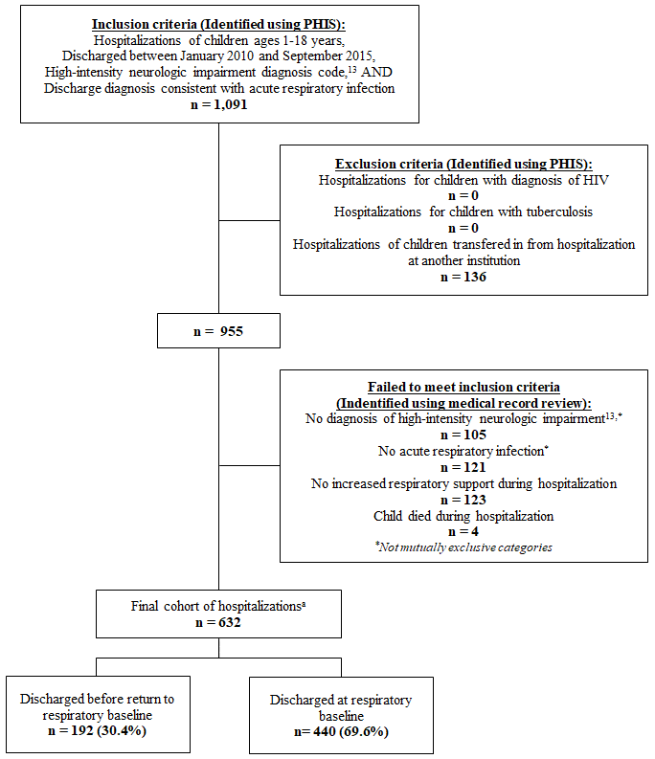

Abbreviations: PHIS, Pediatric Health Information System database; HIV, human immunodeficiency virus.
ªIncluded 632 hospitalizations experienced by 366 children with neurologic impairment admitted with acute respiratory illness and who required increased respiratory support from baseline during hospitalization. The majority of children in the cohort (66.4%) experienced only one hospitalization, 17.5% had two hospitalizations, 7.9% had three hospitalizations, and 8.2% had four or more hospitalizations.

