SUPPLEMENTARY APPENDIX

Improving Respiratory Rate Accuracy in the Hospital: A Quality Improvement Initiative

Neil Keshvani, MD¹; Kimberly Berger, MD, MPH¹; Arjun Gupta, MD^{1;} Sheila DePaola, RN²; Oanh Kieu Nguyen, MD, MAS^{1,3}; Anil N. Makam, MD, MAS^{1,3}

¹Department of Internal Medicine, UT Southwestern Medical Center, Dallas, Texas

²Department of Nursing, Parkland Health and Hospital System, Dallas, Texas
³Department of Medicine, Chan Zuckerberg San Francisco General Hospital, University of California San Francisco

Figure 1. Comparison of respiratory rate measurements…………….…………….……...  Figure 2. Distribution of Respiratory Rates among Control and Intervention Units……...  Table 1. Effect of Intervention to Improve Respiratory Rate Accuracy on SIRS Incidence  Table 2. Study Flow Table for EHR Cohort………………………………………………. | 2  3  4  5

Appendix Figure 1. Comparison of respiratory rate measurements by PCA and trained staff using gold-standard technique before the intervention (Top Panel) and after the intervention (Bottom Panel).
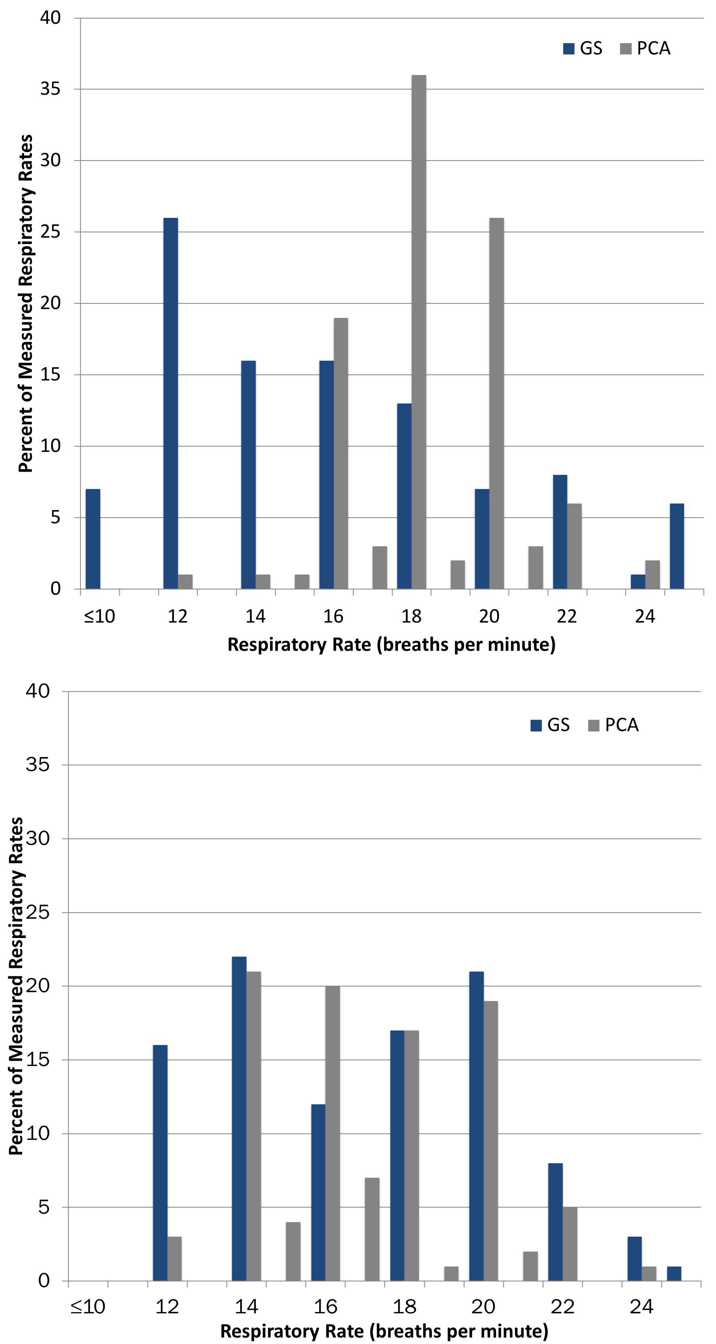
Abbreviations: GS, gold-standard; PCA, patient care assistant

Appendix Figure 2: Distribution of Respiratory Rates among Control and Intervention Units
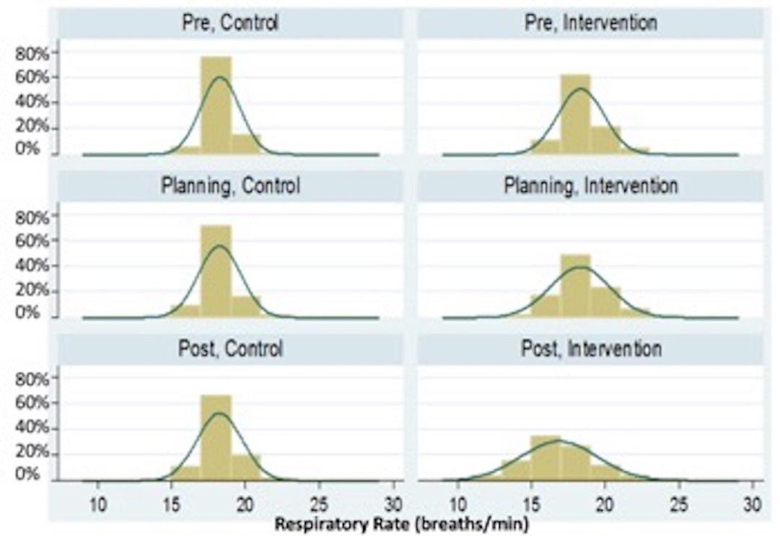

During the pre-intervention phase, the mean RR on the control units (n=48,277) was 18.4 with a standard deviation (SD) ± 4.4 (upper left panel). This was qualitatively similar to the distribution of RRs on the intervention unit (n=19,467; mean RR of 18.3±3.4; upper right panel). Post-intervention, the control unit RRs (n=19,627; lower left panel) qualitatively had a similar distribution and were largely unchanged compared with the pre and planning phases (mean RR of 18.4±4.5, middle left panel). After the intervention, RRs on the intervention unit (n=7,281; lower right panel) had a lower mean±SD of 17.0±4.2 and were qualitatively more normally distributed than pre and planning phases (upper right and middle right panels respectively).

Appendix Table S1. Effect of Intervention to Improve Respiratory Rate Accuracy on SIRS Incidence†
 | Intervention unit |  |  | Control units
Outcome | Pre | Post | Change | Pre | Post | Change | Difference-in-Differences (95% CI)
SIRS incidence*
Vital sign set | 20.8% | 16.3% | -4.5% | 14.4% | 12.9% | -1.5% | -2.9% (-8.3% to +2.4%)
Hospital day | 40.8% | 34.4% | -6.3% | 32.9% | 31.2% | -1.7% | -4.6% (-12.2% to +3.0%)
Hospitalization | 56.5% | 56.6% | 0.1% | 53.9% | 57.2% | 3.3% | -3.2% (-10.2% to +3.7%)
Tachypnea-specific SIRS incidence**
Vital sign set | 2.8% | 2.7% | -0.1% | 1.7% | 1.9% | 0.2% | -0.3% (-1.4% to +0.9%)
Hospital day | 9.8% | 8.8% | -1.0% | 5.9% | 8.2% | 2.3% | -3.3% (-6.4% to -0.0%)
Hospitalization | 24.8% | 21.4% | -3.4% | 16.1% | 20.5% | 4.4% | -7.8% (-13.5% to -2.2%)
Abbreviations: SIRS, systemic inflammatory response syndrome; RR, respiratory rate
† To examine changes in the incidence of tachypnea-specific SIRS and overall SIRS before and after our intervention we used a difference-in-differences approach. This approach compares the change in incidence over time in the intervention unit to the change in incidence in the two control units combined. Therefore, logistic regression models included unit (intervention versus control), time-period, and the interaction between them, which is the difference-in-differences term. From these models we computed marginal effects to estimate SIRS incidence for each time period for each group. We estimated contrasts for differences for each group and the difference-in-differences and robust standard errors using the delta method. Analyses at the vital sign set and hospital day level accounted for clustering by hospitalization. Analyses at the hospitalization level accounted for clustering by patient.
* SIRS incidence was defined as the presence of at least two of four possible criteria simultaneously using time-stamped vital signs and laboratory data from the EHR: temperature >38°C or <36°C, pulse >90 beats/minute, respiratory rate >20 breaths/minute, or a white blood cell count >12,000/mm3 or <4,000/mm. We used last observation carried forward for missing values, which occurred most frequently for WBC count since this is typically obtained once daily, whereas vital signs are typically measured every 4-6 hours.
** Defined as having exactly 2 SIRS criteria, one of which was a respiratory rate>20.

Appendix Table S2. Study Flow Table for EHR Cohort
Exclusion Criteria | Excluded RRs, n (%) | Included RRs, n (%)
- | - | 400,085
Recorded in the emergency department | 46,650 (11.7%) | 353,435
Hospital admission date was before 3/1/17 | 7,528 (2.1%) | 345,907
Patient less than 18 years of age | 46 (0.0%) | 345,861
Patient not admitted to intervention or control units | 120,055 (34.7%) | 225,806
Patient admitted during teaching phase | 7,533 (3.3%) | 218,273
RR obtained off of the intervention or control units | 74,826 (34.3%) | 143,447†
Abbreviations: RR, respiratory rates
† The intervention unit included 39,445 recorded RRs from 1,577 unique hospitalizations and the control units included 104,002 recorded RRs from 5,523 different hospitalizations. Among patients hospitalized on the intervention unit, the median age was 52 (IQR 40-61), 64% were male, 18% non-Hispanic White, 46% Hispanic white, and 32% Black. For patients hospitalized on the control unit, the median age was 54 (IQR 42-63), 56% male, 20% non-Hispanic White, 39% Hispanic white, and 37% Black. The median length of stay (LOS) was similar for both groups (intervention unit median LOS = 3.4 day, IQR 2.1-5.6; control units median LOS = 2.8 days, IQR 1.8-4.9). Lastly, most patients from both groups were discharged home (intervention 92.3%, control 91.2%), with low inpatient mortality (intervention, 0.76%; control units, 0.67%).

