Patient: Jane Doe is a 45 yo female with h/o cocaine use who presents with clumsiness and dysarthria the morning after admission for chest pain. She noted these symptoms when she woke up in the morning.
Date/Time of Stroke Alert: XXXXX @ XXXX
Objectives/Goals based on The Golden Hour of stroke treatment:
≤ 10 min: Stroke Alert Activation, initial MD evaluation, lab work drawn and sent, IV access (min 20 gauge in AC): The pt awoke at XXXX and the Stroke Alert was not called until XXXX. The pts initial symptoms were dizziness.

≤ 15 min: Stroke team notification and arrival: Stroke Team arrived within 15 min of stroke alert.

≤ 25 min: CT scan initiated: CT performed at XXXX (28 min from time of stroke alert, but 7 hours after pt last known well).
≤ 45 min: CT and labs interpreted: Labs and CT interpreted within 45 min of stroke alert.
≤ 60 min: tPA given if patient is eligible: Pt did not receive tPA because she was not eligible due to time since last known well. The pt was not within a window to treat with thrombolysis.
Additional Feedback/Recommendations:
This alert offers the chance to evaluate our stroke alert process. Time to CT scan did not meet goal of 25 minutes and there was a delay in calling stroke alert after symptoms were first noticed. If you have any thoughts or suggestions on barriers experienced or what could be done differently please let us know. Thank you.
The pt was found to have a RMCA stroke likely secondary to cocaine use and hypertension.

R MCA evolving infarct on initial head CT.

UCH Stroke Program Feedback
Closing the Loop
You are receiving this email because you participated in caring for a patient in which a Stroke Alert was called. The Stroke Team would like to provide you with feedback about the Stroke Alert. Please let us know if you
have any questions or comments. Thank you for your continued support of the Stroke Program.
R MCA infarct on subsequent MRI

Thank you for your feedback!
Appendix II
Example Feedback Form

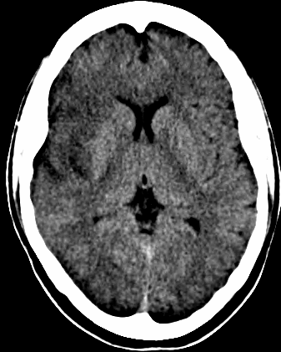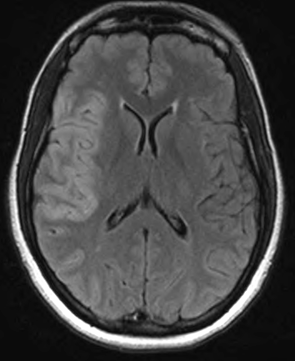
R MCA evolving infarct on initial head CT.

R MCA infarct on subsequent MRI

