Appendix 1 -Interrupted time series
Each interrupted time series can be specified as E(Y) = constant + β0*t + β1*X1+ β2 *t*X1, where Y_{t} is the dependent variable (PPI use), t indicates the order of the observations (fiscal period) and X1 is a dummy variable indicating whether the observation was taken before or after the intervention. In this method we use the pre-intervention period as the control for the post intervention period. If β1 is statistically different from zero this implies there was a change in the absolute level of use of the drug post intervention. If β2 is statistically different from zero this implies there was a change in the trend of use (slope of the line) post intervention. Alpha was p=0.05.

Appendix 2 – PPI audit online tool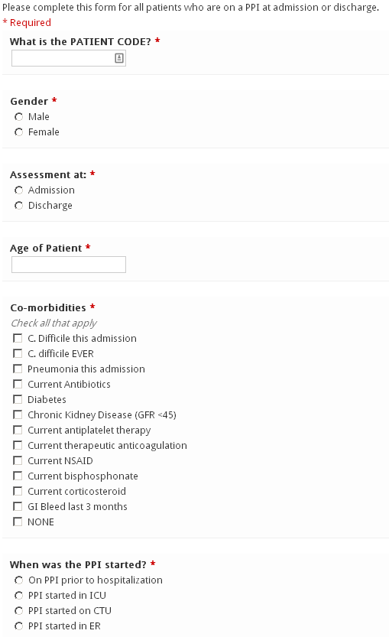
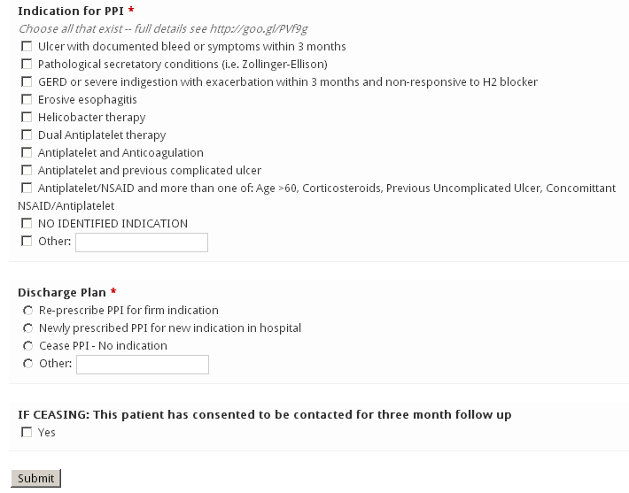

Appendix 3 – Letter to community doctors
Dear Doctor,
Recently both the FDA and Health Canada have sent out advisory notices about the risks of proton pump inhibitor therapy (PPI) including osteoporotic fracture, hypomagnesaemia, and an increased risk of C. difficile associated diarrhea.
As part of an ongoing effort to improve the care of our shared patients, we have reviewed the indications for PPI use in this patient and have recommended that they discontinue at present. To avoid rebound hypersecretion, a tapering dose will have been prescribed in patients who were on high dose therapy or those who have received therapy for greater than six months.
In the event that our information regarding indication was incorrect, we ask that you review the indications for restarting therapy at your next visit. We will also arrange telephone follow up at three months to assess for the efficacy of this intervention and to re-address the indications for PPI use.
Indications:
- Gastric and duodenal ulcer within the past 3 months
  - Further suppression can be accomplished with once daily H2 blockers in high risk patients (complications, frequent recurrences, refractory/giant/fibrosed ulcers)
- Pathological hypersecretory conditions (i.e. Zollinger-Ellison)
- Erosive esophagitis
- GERD with exacerbations within the last 3 months not responsive to H2 blockers and non-pharmacologic techniques
  - Consider 2-4 week pulses of therapy with symptoms for those without severe esophagitis
- Recurring symptoms recently associated with severe indigestion within the last 3 months not responsive to H2 blocker or non-pharmacologic techniques
  - Consider 2-4 week pulses of therapy with symptoms
- Helicobactor pylori eradication
- Prophylaxis for gastropathies associated with long term use of nonsteroidal anti-inflammatory drugs (NSAIDs)
  - (in order of importance: history of complicated ulcer disease, concurrent use of >1 NSAID (including aspirin), use of high NSAID doses, concurrent use of an anticoagulant, history of uncomplicated peptic ulcer disease, age >60, and concurrent use of steroids.)
Kind Regards,

