**Appendix Figure. Cohort derivation**

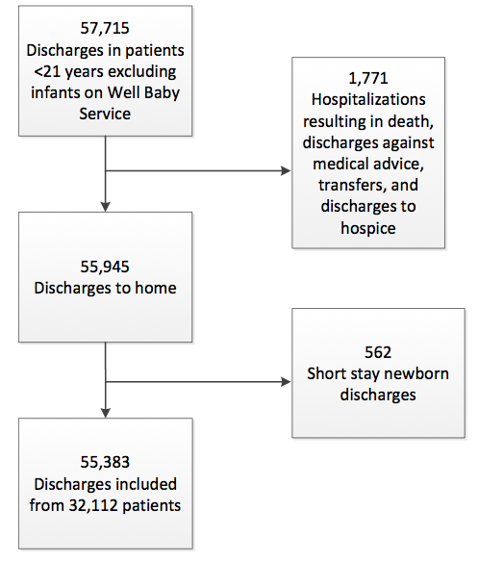

**Appendix Table: Covariates—Patient Characteristics During Hospitalizations**

|  |  |  |  |  |  |
| --- | --- | --- | --- | --- | --- |
|  | | **Frequency (%), Number of hospitalizations** | **Unadjusted Odds of Readmission (95% CI)** | **Weekend Admission Model: Adjusted Odds of Readmission (95% CI)** | **Weekend Discharge Model: Adjusted Odds of Readmission (95% CI)** |
| **Age category** | Admit on birthday | 3.1, n=1,734 | 0.79 (0.66-0.94)* | 0.64 (0.50-0.82)* | 0.65 (0.51-0.83)* |
| <=1 yr, non newborn | 18.4, n=10,182 | Ref | Ref | Ref |
| >1 yr, <=5 yrs | 24.3, n=13,480 | 0.97 (0.87-1.09) | 0.93 (0.83-1.03) | 0.93 (0.83-1.03) |
| >5 yrs, <=10 yrs | 17.8, n=9,846 | 0.85 (0.74-0.98)* | 0.83 (0.73-0.95)* | 0.83 (0.73-0.95)* |
| >10 yrs, <=15 yrs | 18.7, n=10,379 | 0.86 (0.75-0.99)* | 0.84 (0.74-0.96)* | 0.84 (0.74-0.96)* |
| >15 yrs, <=21 yrs | 17.6, n=9,762 | 1.04 (0.91-1.19) | 0.95 (0.83-1.09) | 0.95 (0.83-1.09) |
| **Gender** | Male | 54.3, n= 30,092 | Ref | Ref | Ref |
| Female | 45.7, n=25,291 | 0.96 (0.87-1.06) | 0.99 (0.91-1.08) | 0.99 (0.91-1.08) |
| **Admission Source** | Emergency Department | 41.8, n=23,133 | Ref | Ref | Ref |
| Transfer from other facility | 6.8, n=3,785 | 1.01 (0.90-1.14) | 0.67 (0.58-0.76)* | 0.66 (0.58-0.76)* |
| Clinic | 6.7, n=3,729 | 2.55 (2.29-2.85)* | 1.81 (1.62-2.04)* | 1.78 (1.59-1.99)* |
| Home | 8.2, n=4,519 | 1.14 (1.02-1.27)* | 0.94 (0.84-1.05) | 0.93 (0.83-1.04) |
| Procedure related | 28.1, n=15,568 | 0.47 (0.43-0.52)* | 0.39 (0.35-0.43)* | 0.38 (0.35-0.42)* |
| Other | 8.4, n=4,649 | 0.61 (0.52-0.71)* | 0.72 (0.58-0.88)* | 0.70 (0.57-0.86)* |
| **Race / Ethnicity** | Non-Hispanic, White | 74.9, n=41,463 | Ref | Ref | Ref |
| Non-Hispanic, African American | 12.7, n=7,017 | 1.24 (1.06-1.44)* | 1.07 (0.92-1.24) | 1.07 (0.92-1.24) |
| Hispanic | 3.0, n=1,656 | 1.16 (0.84-1.58) | 1.00 (0.76-1.32) | 1.00 (0.76-1.32) |
| Asian/South Asian | 2.7, n=1,467 | 0.86 (0.68-1.09) | 1.07 (0.86-1.34) | 1.07 (0.86-1.35) |
| Other | 2.9, n=1,606 | 1.08 (0.85-1.38) | 1.03 (0.84-1.27) | 1.03 (0.84-1.27) |
| Unknown/Refused | 3.9, n=2,174 | 0.64 (0.46-0.90)* | 0.67 (0.49-0.91)* | 0.67 (0.49-0.91)* |
| **Primary Payer Type** | Private | 64.1, n=35,510 | Ref | Ref | Ref |
| Medicaid/Government | 35.5, n=19,651 | 1.41 (1.28-1.55)* | 1.25 (1.14-1.37)* | 1.25 (1.14-1.37)* |
| Other, includes self pay | 0.4, n=222 | 0.62 (0.36-1.05) | 0.74 (0.44-1.25) | 0.74 (0.44-1.25) |
| **Median Length of Stay, days (interquartile range)** | | 3 (1, 5) | 1.01 (1.01-1.02)* | 1.01 (1.01-1.01)* | 1.01 (1.01-1.01)* |
| **Number of Complex Chronic Conditions** | 0 | 46.8, n=25,933 | Ref | Ref | Ref |
| 1 | 35.9, n=19,867 | 2.94 (2.70-3.21)* | 2.91 (2.65-3.18)* | 2.90 (2.65-3.18)* |
| 2 | 11.9, n=6,588 | 4.16 (3.75-4.60)* | 3.84 (3.42-4.31)* | 3.83 (3.42-4.30)* |
| 3 | 4.1, n=2,251 | 5.76 (5.01-6.62)* | 4.95 (4.21-5.82)* | 4.94 (4.20-5.81)* |
| 4+ | 1.3, n=744 | 6.48 (5.33-7.86)* | 4.96 (3.96-6.23)* | 4.96 (3.95-6.23)* |
| **Technology Dependency** | No | 87.3, n=48,340 | Ref | Ref | Ref |
| Yes | 12.7, n=7,043 | 2.25 (2.05-2.47)* | 1.10 (0.99-1.22) | 1.10 (0.99-1.22) |

*p<0.05