In analyzing VA Decision Support System (DSS) Costs, we first analyzed the distribution of the cost outcomes. This clearly demonstrates the non-normal distribution of costs.

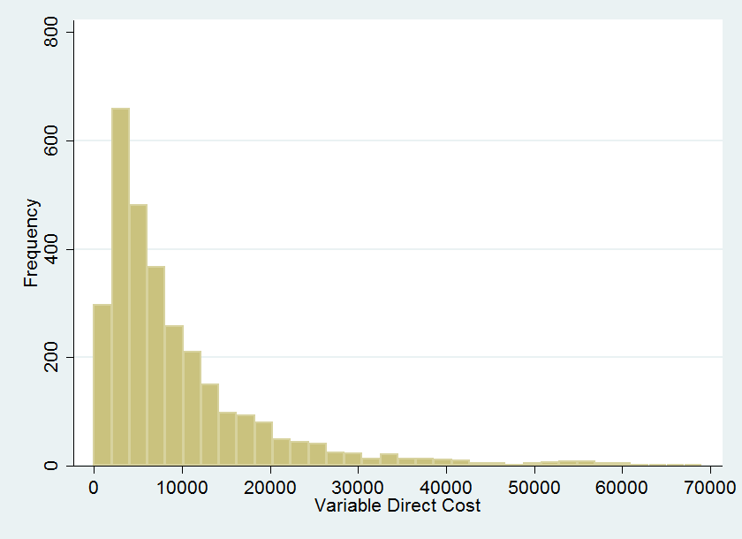

The VA DSS has a difficult time with short hospital stays. An analysis of our missing cost data (n=168) and length of stay finds that most missing data is on patients admitted for 1 day.

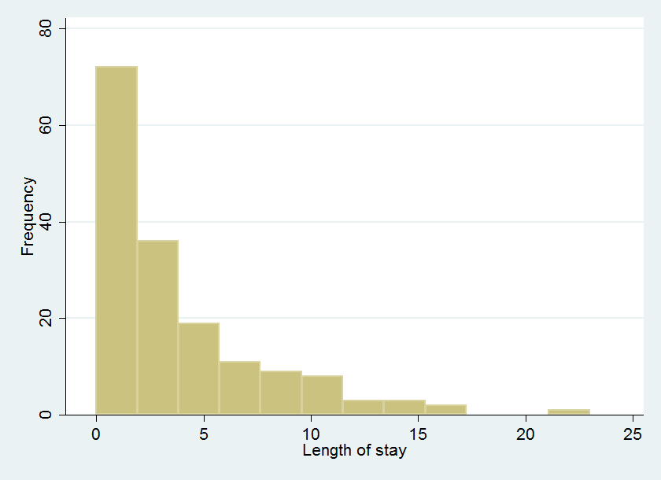

To account for the missing data, we present three analytic strategies: a) no imputation, b) average daily cost * length of stay, and c) multiple imputations (n=20) of the missing data. We were successfully able to impute the missing cost data. Among the methods, the differences between methods are <$100.

|  |  |
| --- | --- |
| Method | Variable Direct Costs  mean(SD)  Median |
| No imputation  (n=3027) | $10649 ($14599)  $6509 |
| Daily Cost X Length of Stay (n=3195) | $10594 (14663)  $6463 |
| Multiple Imputation  (n=3195) | $10674 (14788)  $6509 |

For the comparison of variable direct cost, those with abnormal mRASS have higher VDC (9% higher).

|  |  |  |
| --- | --- | --- |
|  | Normal mRASS  mean(SD)  median | Abnormal mRASS  mean(SD)  median |
| Variable Direct Costs | 10568 (15099)  6298 | 11731(13733)  7860 |

We performed three regression analyses on the imputed data: a) Poisson, b) Negative binomial, and c) log link generalized linear model with a gamma distribution. There is considerable debate as to the ‘best’ model for cost analyses. Our cost data best fit a Poisson distribution. However, the other methods returned similar results.

|  |  |
| --- | --- |
| Model type | IRR (95%CI) |
|  |  |
| Poisson | 1.07 (0.95, 1.20) |
| Negative Binomial | 1.07 (0.95, 1.20) |
| Log link with Gamma Distribution | 1.07 (0.95, 1.20) |