**Supplement: Online Web Appendix**

**eFigure 1** Flow Diagram of Study Selection

**eFigure 2** Risk Ratios for 90-day Readmission for Depressed Compared to Not Depressed Patients

Legend: Forest plot that presents results of meta-analysis. The size of each data marker indicates the weight assigned to individuals studies.

**eFigure 3** Risk Ratios for 90-day Mortality for Depressed Compared to Not Depressed Patients

Legend: Forest plot that presents results of meta-analysis. The size of each data marker indicates the weight assigned to individuals studies.

**eTable 1** Newcastle-Ottawa Quality Assessment for Observational Studies

**eFigure 1** Flow Diagram of Study Selection



**eFigure 2** Risk Ratios for 90-day Readmission for Depressed Compared to Not Depressed Patients

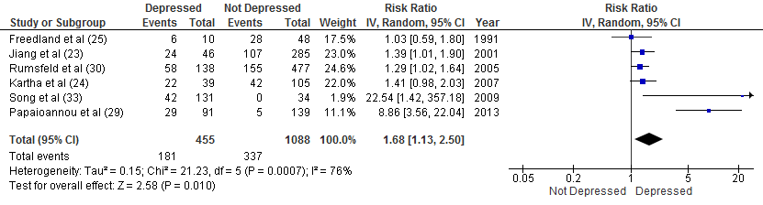

**eFigure 3** Risk Ratios for 90-day Mortality for Depressed Compared to Not Depressed Patients

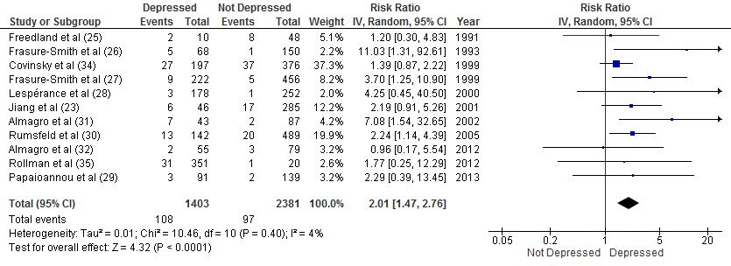

|  |  |  |  |  |  |  |  |  |  |
| --- | --- | --- | --- | --- | --- | --- | --- | --- | --- |
| **eTable 1 Newcastle-Ottawa Quality Assessment for Observational Studies** | | | | | | | | | |
| Author and Date of Publication | Selection 'generalizability' | | | | Comparability | Outcome | | |  |
|  | Representative exposure group | Selection unexposed group | Exposure ascertainment exposure | Outcome not present at baseline | Comparable groups | Assessment of outcome | Adequate Follow up length? (yes ≥ 1 mth/no ≤ 1 mth) | Adequate follow-up | Score |
| Almagro et al,38 2002 | selected group | same | interview | yes | yes | self-report or record linkage | yes | LTFU ≤20% | 7 |
| Almagro et al,39 2012 | selected group | same | interview | yes | yes | self-report or record linkage | yes | LTFU ≤20% | 7 |
| Büla et al,46 2001 | somewhat | same | interview | yes | yes | self-report or PCP report | yes | LTFU ≤20% | 8 |
| Cancino et al,29 2014 | somewhat | same | interview | yes | yes, yes | blind assessment, record linkage, and self-report | yes | LTFU ≤20% | 9 |
| Mitchell et al,43 2010 | somewhat | same | interview | yes | yes, yes | blind assessment, record linkage, and self-report | yes | LTFU ≤20% | 9 |
| Covinsky et al,41 1999 | somewhat | same | interview | yes | yes | record linkage | yes | complete | 9 |
| Jiang et al,30 2001 | somewhat | same | interview | yes | yes | self-report | yes | LTFU ≤20% | 7 |
| Kartha et al,31 2007 | selected group | same | interview | yes | yes, yes | record linkage and self-report | yes | complete | 8 |
| Frasure-Smith et al,33 1993 | selected group | same | interview | yes | yes, yes | self-report, medical records | yes | complete | 7 |

|  |  |  |  |  |  |  |  |  |  |
| --- | --- | --- | --- | --- | --- | --- | --- | --- | --- |
| **eTable 1 Newcastle-Ottawa Quality Assessment for Observational Studies** (continued) | | | | | | | | | |
| Author and Date of Publication | Representative exposure group | Selection unexposed group | Exposure ascertainment exposure | Outcome not present at baseline | Comparable groups | Assessment of outcome | Adequate Follow up length? (yes ≥ 1 mth/no ≤ 1 mth) | Adequate follow-up | Score |
| Frasure-Smith et al,34 1999 | selected group | same | interview | yes | yes, yes | blind independent assessment, record review, and self-report | yes | complete | 9 |
| Lespérance et al,35 2000 | selected group | same | interview | yes | yes, yes | blind independent assessment, medical record, and self-report | yes | complete | 9 |
| Papaioannou et al,36 2013 | selected group | same | interview | yes | yes | blind assessment, self-report, hospital records | yes | LTFU ≤20% | 7 |
| Song et al,40 2009 | selected group | same | interview | yes | yes | self-report, record review | yes | LTFU ≤20% | 6 |
| Freedland et al,32 1991 | selected group | same | interview | yes | yes | self-report | yes | complete | 7 |
| Rollman et al,42 2012 | selected group | same | interview | yes | yes, yes | self-report, medical records | yes | complete | 7 |
| Rumsfeld et al,37 2005 | selected group | same | interview | yes | yes | blind independent assessment | yes | LTFU ≤20% | 7 |
| Fulop et al,45 2003 | selected group | same | interview | yes | yes | self-report | yes | unclear | 5 |
| Koenig and Kuchbhatla et al,44 1999 | somewhat | same | interview | yes | yes | self-report | yes | LTFU >20% | 6 |