Appendix 2: Scatterplot arrays showing the distribution of HR and RR measurements in the validation set.

(A) and (C) using currently adopted 2004 NIH reference ranges (B) and (D) using proposed data-driven 5th/95th percentile ranges. Within range observations are colored black and out-of-range observations are red.

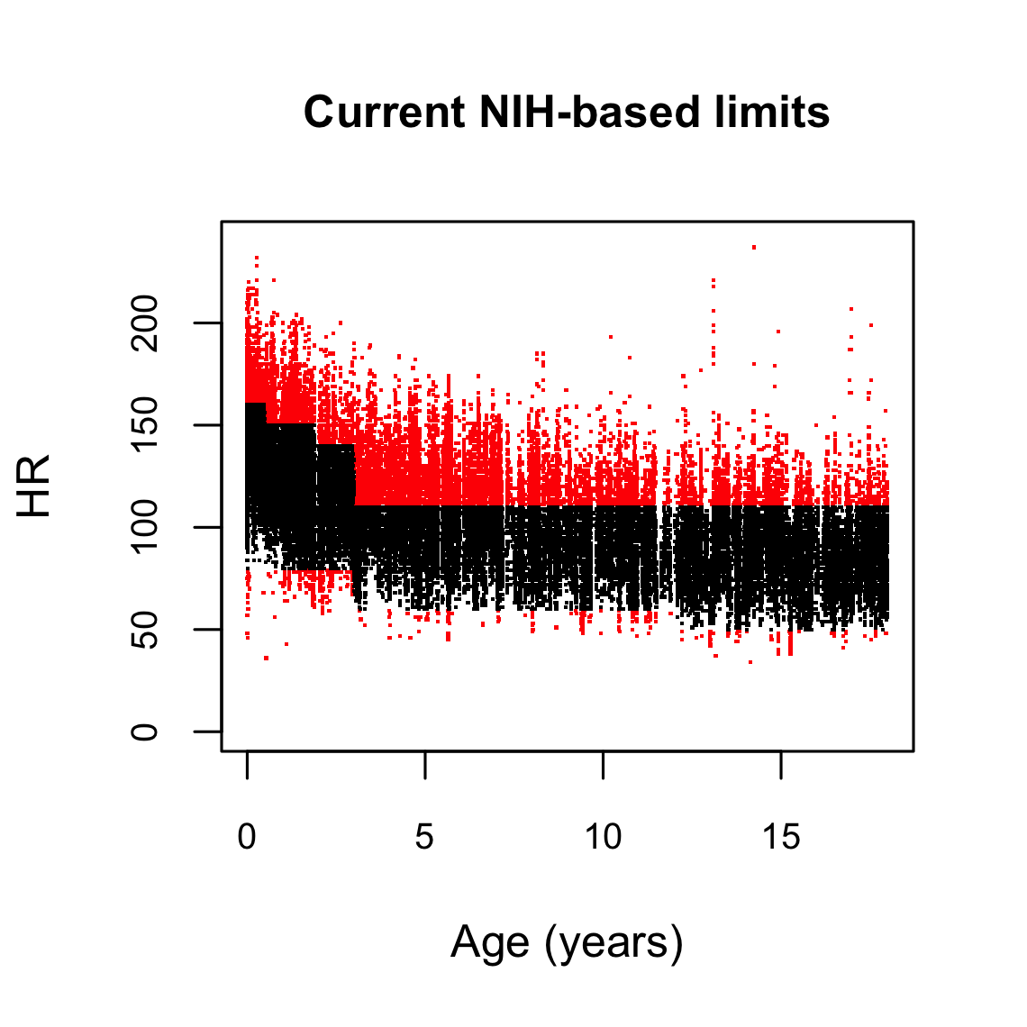
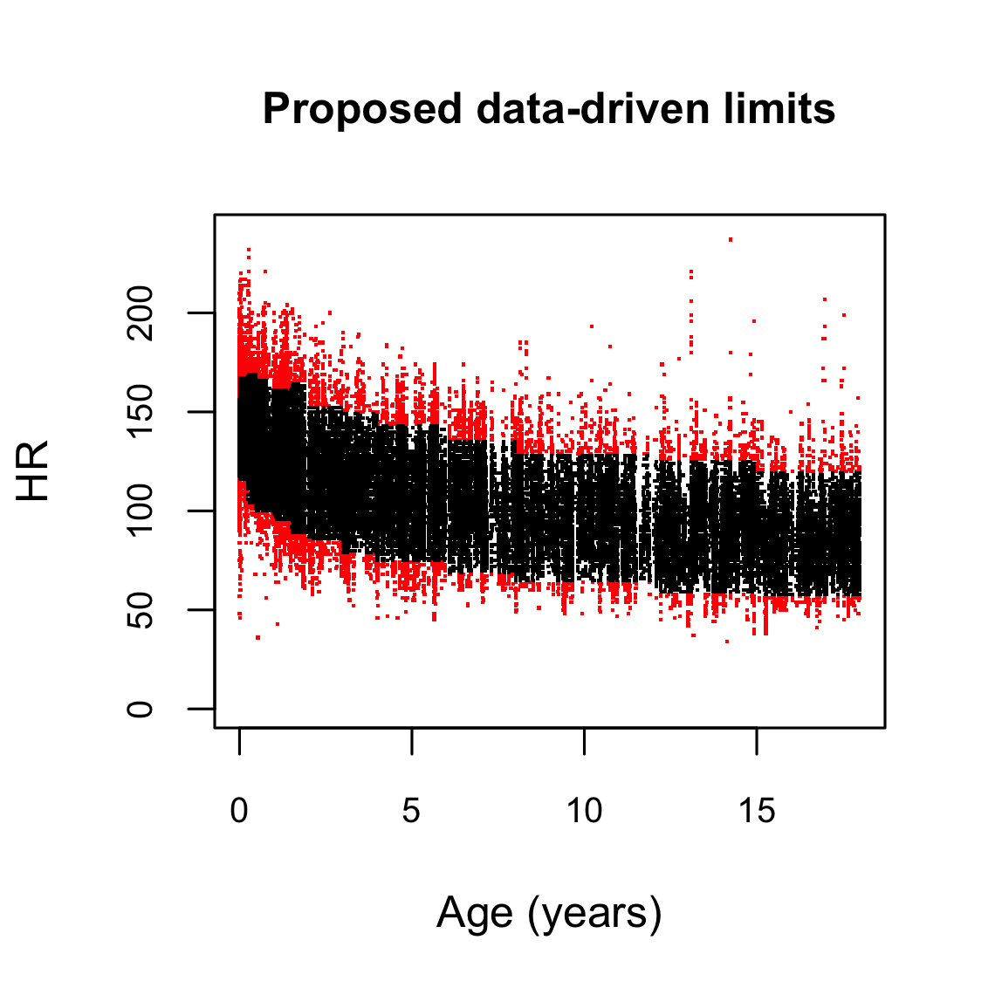
A. B.

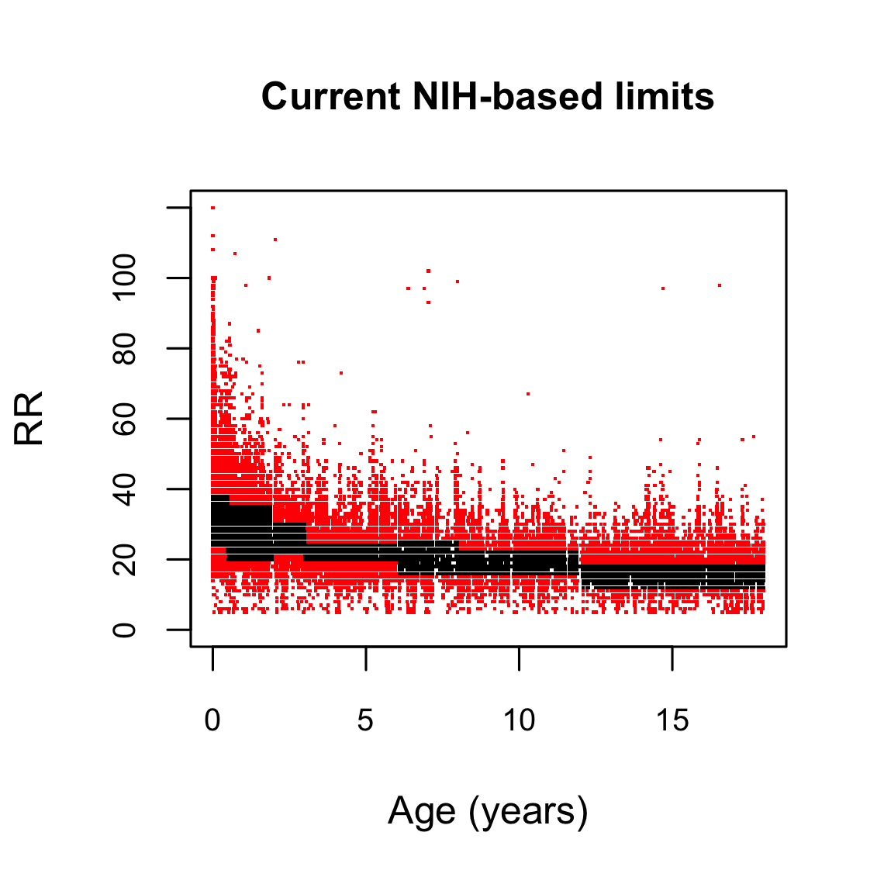
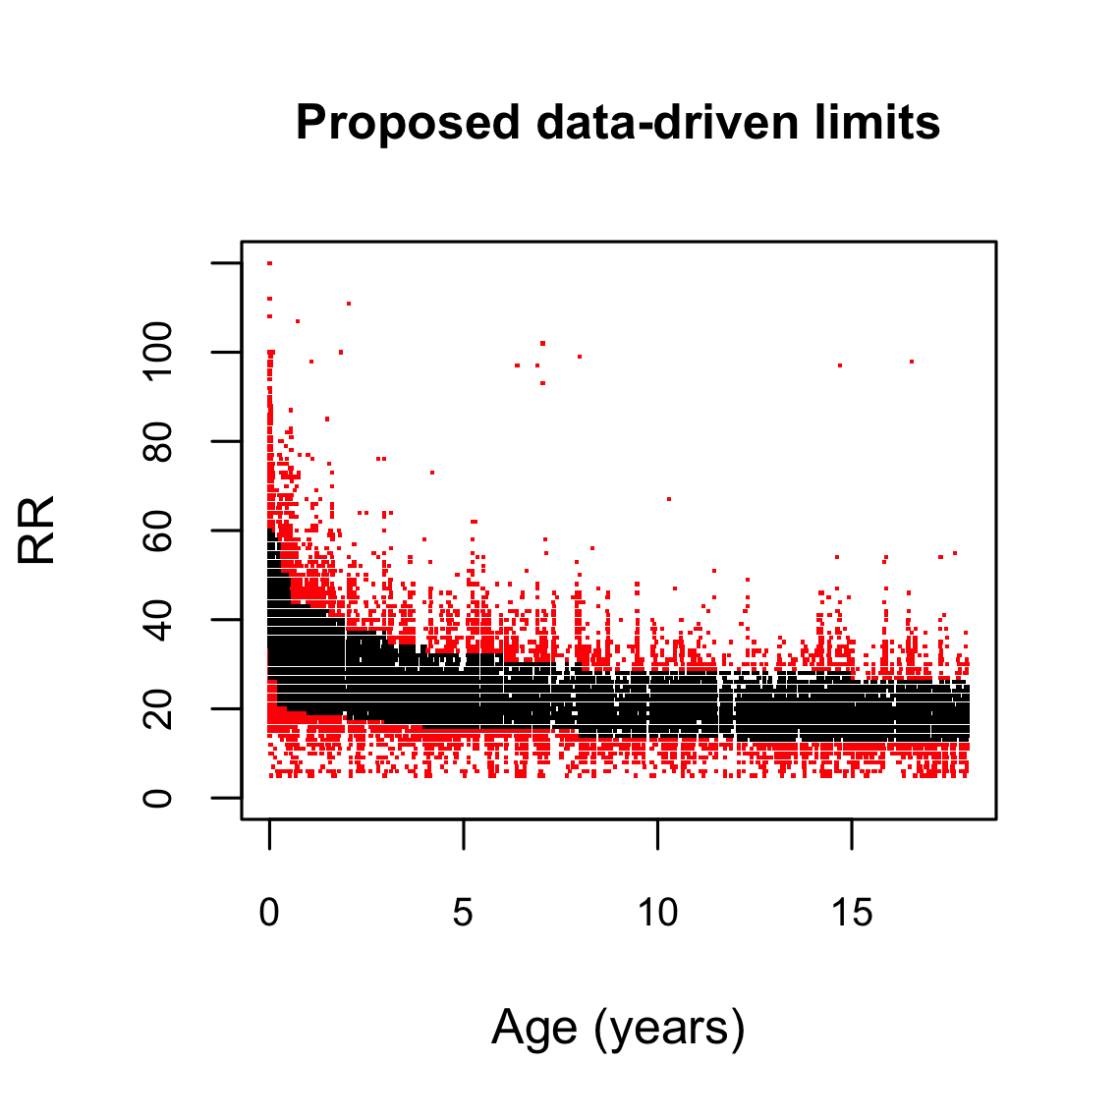
C. D.

