Development of a successful performance improvement program for early detection and treatment of severe sepsis in general medical-surgical wards
Web Appendix
Appendix 1. Screening compliance template (page 2)
Appendix 2. Clinician report card template sample (page 3)
Appendix 2. Report card template modified single patient sample (page 4)

Appendix 1. Screening compliance template
Modified from SSC Phase IV Collaborative Learning Session 1

Appendix 2. Clinician report card template
Template sample 1
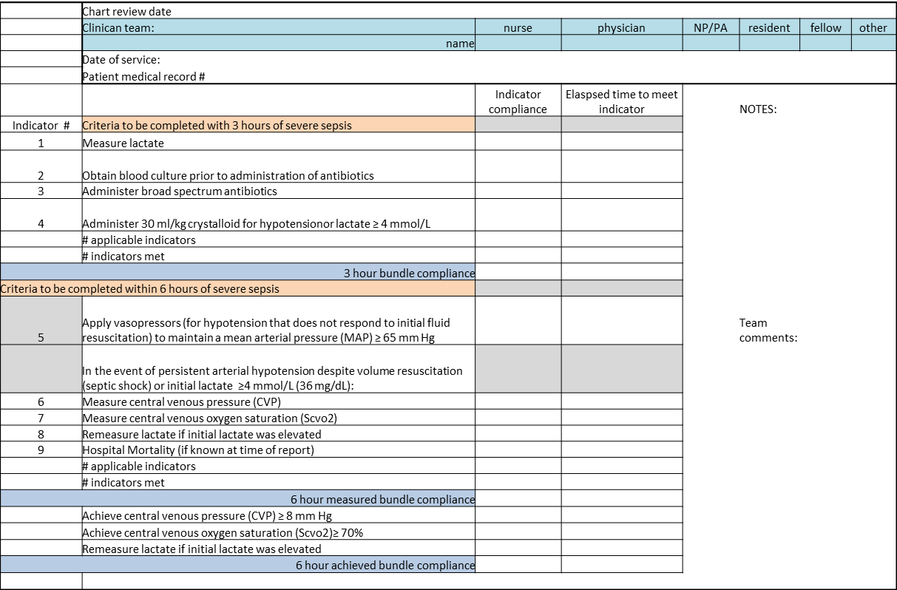

Appendix 3. Report card template Modified single patient
SSC database 3 hour bundle compliance
 |  |  | Clinical team Severe Sepsis Report Card
Clinical team: | nurse | physician | NP/PA | resident | fellow | other
name
3 hour bundle
